


School Uniform Policy

This policy is effective for all schools within The Mead Educational Trust, the Teaching School, the SCITT and all other activities under the control of the Trust and reporting to the Trust Board.
Version: | 3.0
Ratified by: | Executive Team
Date ratified: | 1st July 2025
Last reviewed: | June 2025
Next review: | June 2027

Revision History:

Version | Date | Author | Summary of Changes:
1.0 | Feb 2023 | ET | New policy
2.0 | Nov 2024 | TH | Inclusion of the Equality and Human Rights Commission's guidance on preventing hair discrimination in schools.
3.0 | June 2025 | TH | Detail of the need to have no more than three branded items (except a school tie).

School Uniform Policy

Aims

This policy aims to:
- Set out our approach to requiring a uniform that is of reasonable cost and offers the best value for money for parents and carers
- Explain how we will avoid discrimination in line with our legal duties under the Equality Act 2010
- Clarify our expectations for School uniform.

2. Our School’s legal duties under the Equality Act 2010

The Equality Act 2010 prohibits discrimination against an individual based on the protected characteristics, which include sex, race, religion or belief, and gender reassignment.

To avoid discrimination, our School will:
- Avoid listing uniform items based on sex, to give all students the opportunity to wear the uniform they feel most comfortable in or that most reflects their self-identified gender
- Make sure that our uniform expectations, and thus costs, are the same for all students within the school
- Allow all students to have long hair (though we reserve the right to ask for this to be tied back) and coloured hair (as deemed appropriate by the School).
- Allow an inclusive environment by adopting The Equality and Human Rights Commission's guidance on preventing hair discrimination in schools.
- Allow students to request changes to swimwear for religious reasons. Schools will consider each request individually and make reasonable adjustments where possible. It will remain the School’s decision to allow any change
- Allow students to wear headscarves and other religious or cultural symbols
- Allow for potential adaptations to our policy on the grounds of equality and protected characteristics by asking students or their parents to contact Mr Godwin ggodwin@brookvalegroby-tmet.uk, who can answer questions about the policy and respond to any requests

3. Limiting the cost of school uniform

Our school has a duty to make sure that the uniform we require is affordable, in line with statutory guidance from the Department for Education on the cost of school uniform.

We understand that items with distinctive characteristics (such as branded items, or items that must have a school logo or a unique fabric/colour/design) cannot be purchased from a wide range of retailers and may limit parents’ ability to ‘shop around’ for a low price.

With this in mind, we will make sure that our uniform:
- Is available at a reasonable cost
- Limits the number of branded items required to three (secondary schools are permitted a fourth branded item, if it is a branded tie)
- Provides the best value for money for parents/carers

We will do this by:
- Limiting any items with distinctive characteristics where possible: for example, by only asking that the school logo is on jumpers/cardigans and PE items.
- Limiting items with distinctive characteristics to low-cost or long-lasting items, such as ties and shirts
- Avoiding specific requirements for items students could wear on non-School days, such as coats, bags and shoes
- Keeping the number of branded items to a minimum including PE kit
- Avoiding different uniform requirements for different year/class/house group and for extra-curricular activities
- Avoiding frequent changes to uniform specifications and minimising the financial impact on parents of any changes
- Ensuring that uniform supplier arrangements give the highest priority to cost and value for money (including the quality and durability of the garment).
- Making sure that arrangements are in place for parents to acquire second-hand uniform items
- Consulting with parents and students on any proposed significant changes to the uniform policy and carefully considering any complaints about the policy

4. Expectations for School uniform

Our School’s uniform

Key Stage 3 – Years 7, 8, 9:

Students in Years 7, 8 and 9 wear a bright blue jumper/cardigan and tie.

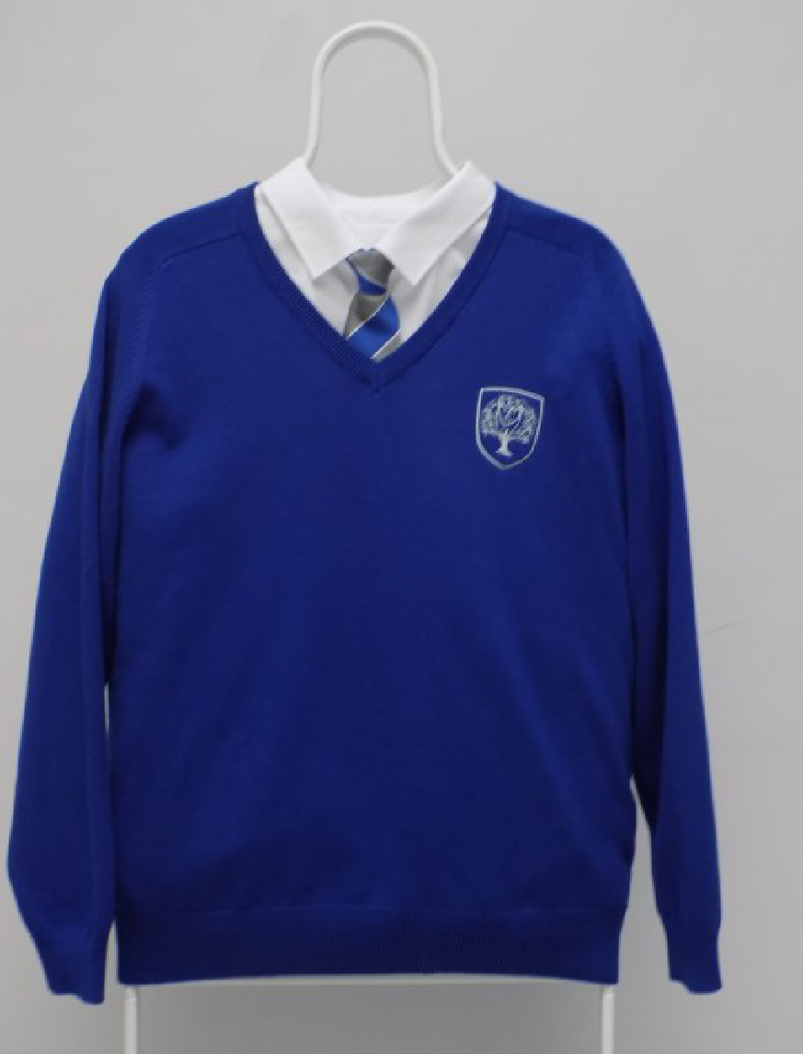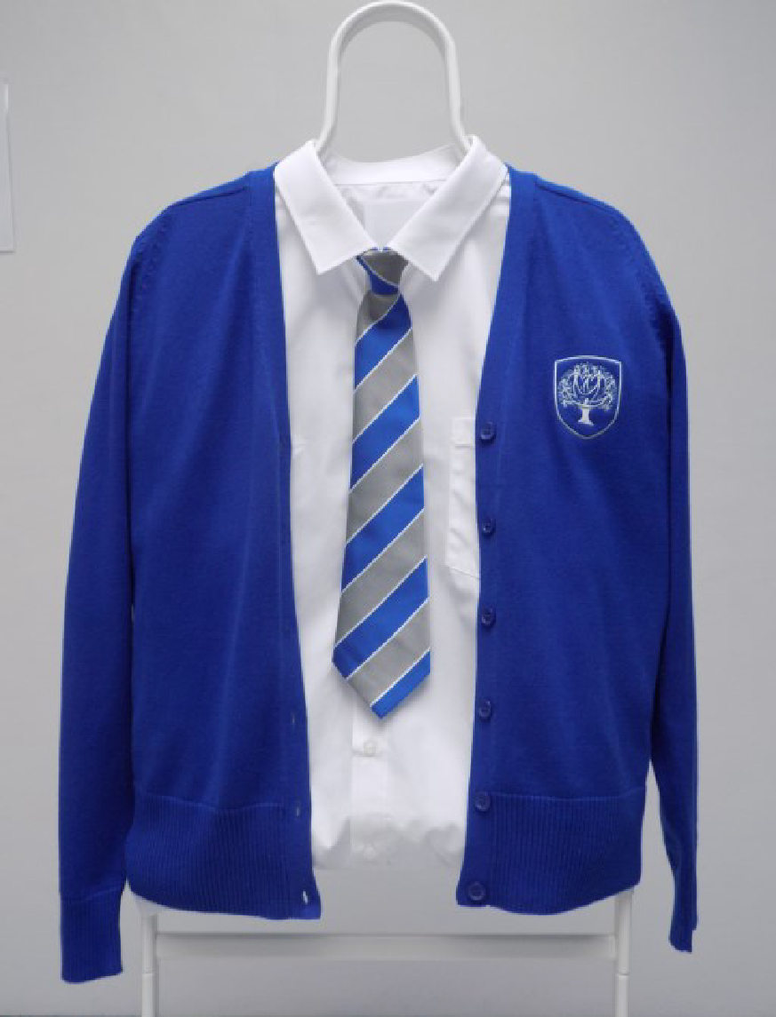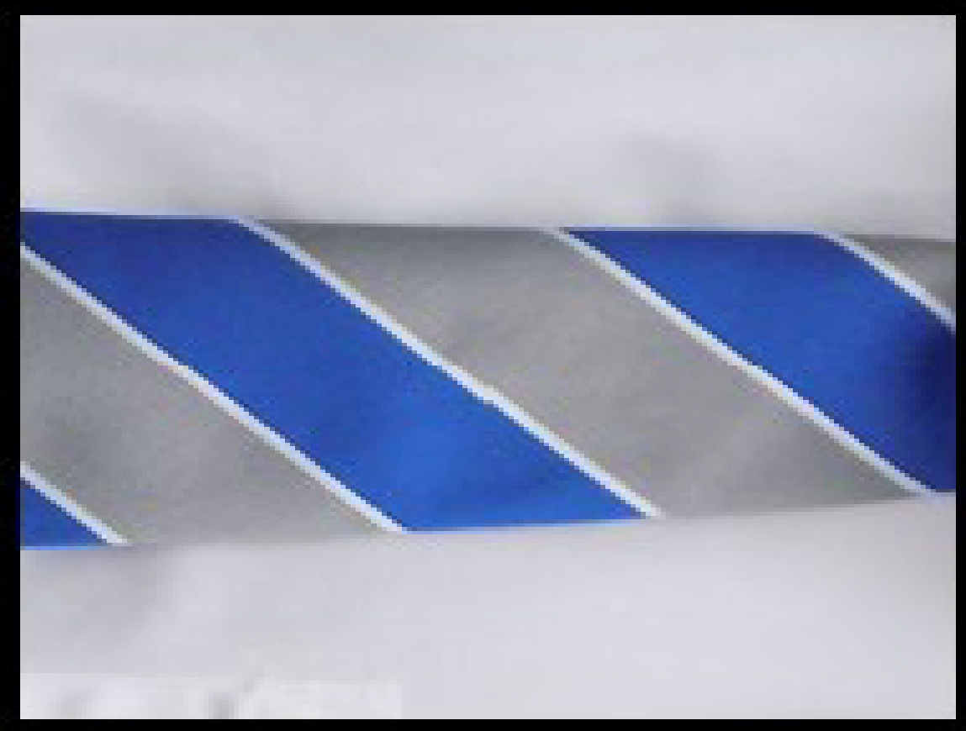

Key Stage 4 – Years 10, 11:

Students in Years 10 and 11 wear a navy jumper/cardigan and tie.

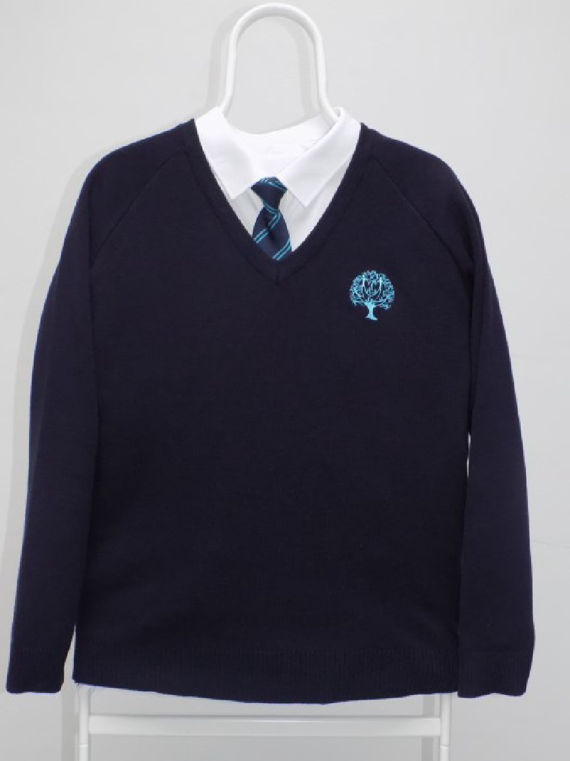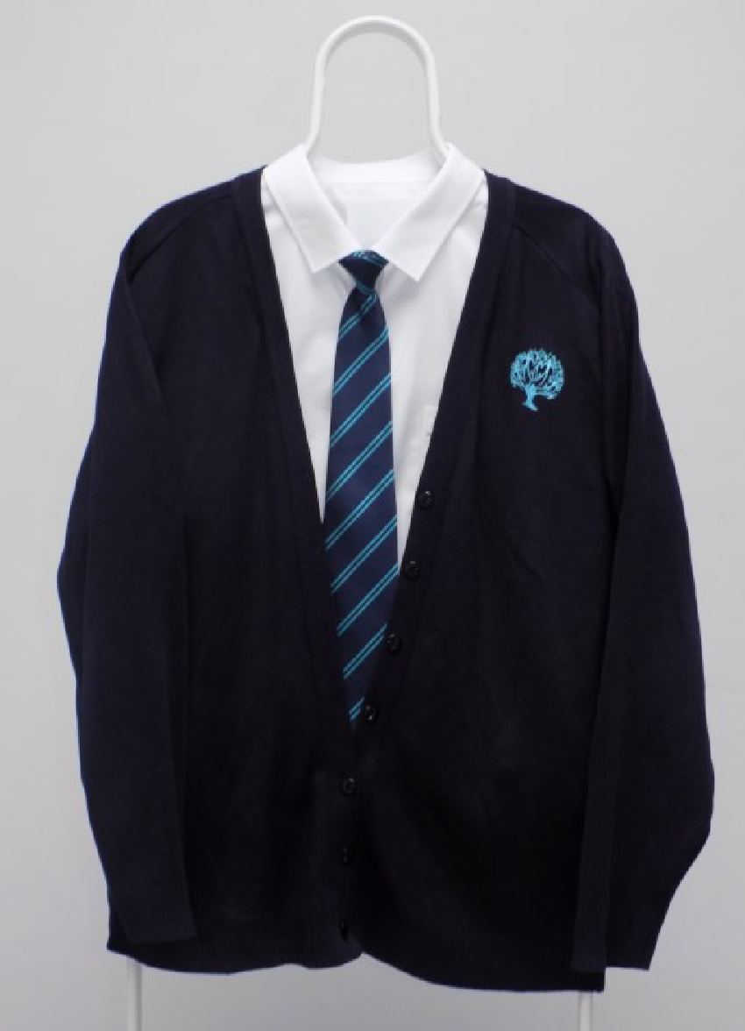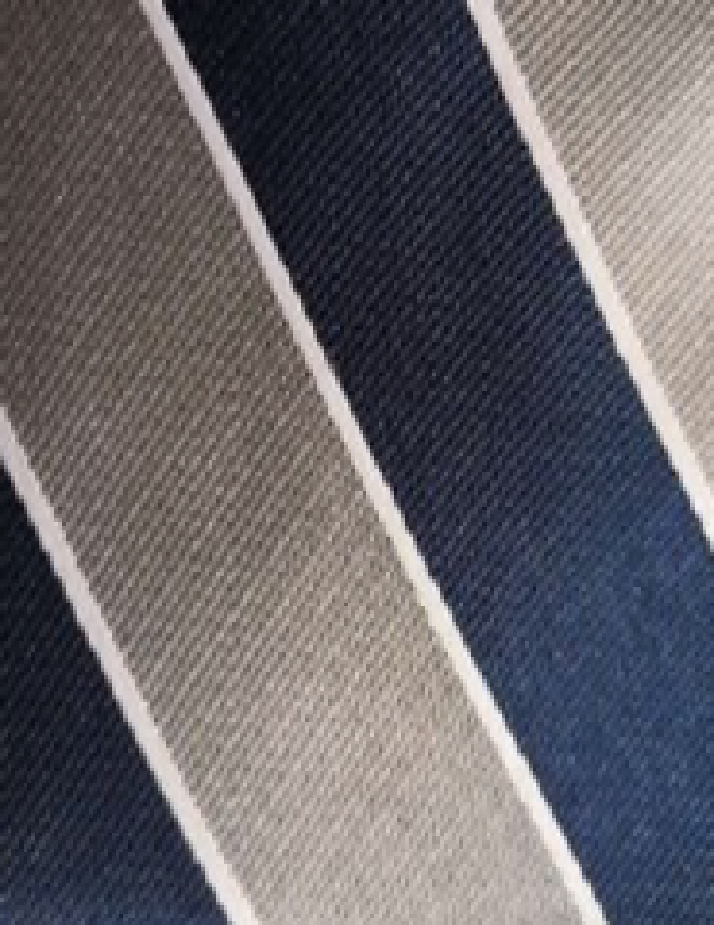

PE Kit – Years 7 – 11:

Our campus PE kit is the same for all Key Stage 3 and 4 students.

This is only available from Uniform Direct (see below).

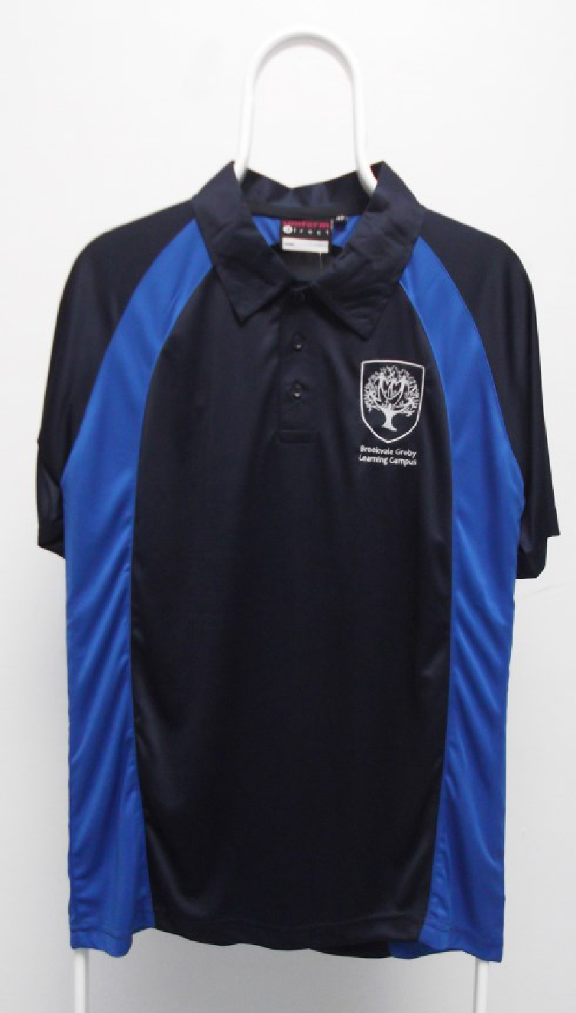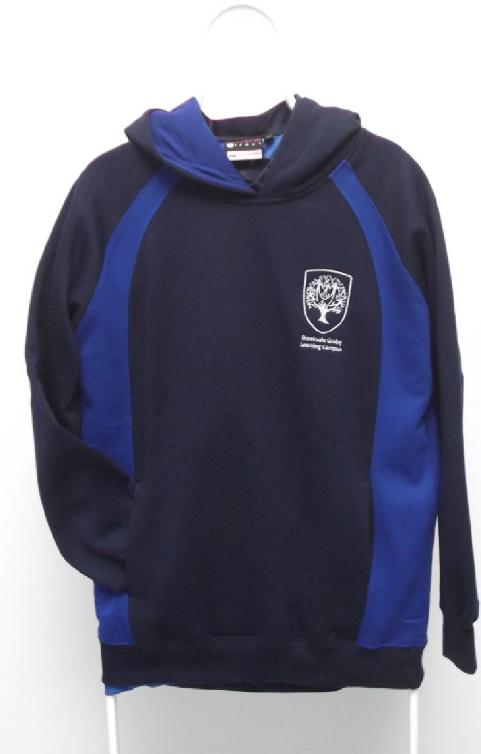

Uniform Guidance:

This guidance is provided to ensure that items purchased by parents/carers adhere to the correct specification:
Item | Guidance
V-neck jumper or cardigan with school logo. | All students must have a school logo jumper or  cardigan. The school jumper or cardigan must always be the next layer after the white shirt. They should not be tucked into skirts or trousers when worn.  A jacket, hoodie or coat must not be worn as a replacement for the school jumper or cardigan.
Clip-on tie. | A tie must be worn at all times (including break and lunchtime) except when participating in PE.
Plain black tailored, formal school trousers / shorts. | We do not allow:  denim, rivets, leggings, low-waisted trousers,  chinos, trousers that are tight on the legs or made of a stretchy material, trousers made of any fabric  other than standard school trouser fabric, drawstring, nor any  trousers that follow a current fashion trend.
Pleated or partially pleated black skirt. | Skirts must be fully pleated or pleated with a front plain panel. No stretchy skirts/skater skirts/pencil skirts.
White formal school shirt with stiff collar and short/long sleeves. | Shirts must be buttoned up to the neck. Shirts must be long enough to be tucked into trousers/skirts at all times
Plain black flat or low heel school shoes/boots or plain black trainers. | No crocs, sandals, or high heels. The soles of all shoes/boots must be black. Trousers cannot be tucked into boots.
Socks and Leg Coverings. | Socks must be plain black.  Tights must be plain, black opaque. If black leggings are worn under a skirt, they must be with black ankle socks long enough so that the ankle is not showing.
PE Kit.  Campus Polo Shirt and Campus Hoodie.  Navy / black shorts/jogging bottoms.  Navy / black socks. | Compulsory campus PE Polo Shirt and Campus Hoodie. Shorts or jogging bottoms must be plain navy.
Trainers and socks for PE. | Can be any colour but must be different from items worn during the school day.

Accessories:
Please note and be aware of the campus rules regarding the following:

Jewellery:
- One pair of small sleeper or stud earrings is permissible.
- No tongue or facial piercings/rings/bangles/bracelets/necklaces.
- A standard watch is permissible, but not a smart watch.

Make-up:
- Light make-up is permitted however it must be discreet.
- If staff believe that make-up is too noticeable, removal will be requested.

Nails:
- No acrylic/false nails.
- No nail varnish (other than clear) is permitted.

Other Accessories:
- Belts, hairbands etc should be plain black and discreet.

Outerwear:
- Hoodies may not be worn at school.
- All outside wear must be removed in school lessons, assemblies etc.
- Hats/hoods must be taken off and kept off whilst in the school buildings.

Where to purchase it

Our designated supplier is Uniform Direct – www.uniform-direct.com (Delivery is free for orders over £29 and all returns are free of charge).

In store – direct from the Uniform Direct shop in Leicester City Centre. 54-56 Humberstone Gate Leicester, LE1 3PJ* Open 9am to 5:30pm, Monday to Saturday. Tel: 0116 2511844.

*The Uniform Direct shop is located next to Sainsburys and should not be confused with another uniform supplier located on the corner of Charles Street, which does not stock our uniform.
The school has a limited in-house supply of some jumpers and cardigans (new) plus various second-hand items, which have been kindly given to us by students who no longer need them. Please enquire at Reception for more information about the items we have available. There is no charge for these items, but a money donation is optional.

5. Expectations for our School community

Students
Our students wear the Brookvale Groby Learning Campus uniform with pride. The uniform is an important part of our School’s identity and standing within our community. We ask that students wear their uniform correctly at all times including:
- On the School premises
- Travelling to and from School
- At out-of-School events or on trips that are organised by the School, or where they are representing Brookvale Groby Learning Campus.
Students are also expected to contact Mr Godwin ggodwin@brookvalegroby-tmet.uk if they want to request an amendment to the uniform policy in relation to their protected characteristics.

Parents and carers
We ask that parents and carers work in partnership with the School by ensuring that their child has the correct uniform and PE kit, and that every item is:
- Clean
- Clearly labelled with the child’s name
- In good condition
Parents are also expected to contact Mr Godwin ggodwin@brookvalegroby-tmet.uk if they want to request an amendment to the uniform policy in relation to:
- Their child’s protected characteristics
- The cost of the uniform
The School is committed to working with parents to resolve any concerns regarding School uniform. Parents are expected to lodge any complaints or objections relating to the School uniform in a timely and reasonable manner and the School will work closely with parents to arrive at a mutually acceptable outcome. Any disputes about the cost of uniform will be:
- Resolved locally
- Dealt with in accordance with our Trust’s complaints policy

The School
The School will ensure that the expectations for students and for parents and carers are clearly communicated; the School uniform policy will be published on the School’s website, and be made available for all parents, including parents of prospective students.
To support parents and families the School will:
- assess the overall cost implications of the uniform policy for parents and carers
- ensure that uniform supplier arrangements give the highest priority to cost and value for money (including the quality and durability of the garment).
- put in place arrangements for parents and carers to acquire second-hand uniform items

The School will work proactively with parents and students to ensure that uniform expectations are met. Where a student is not wearing the expected uniform, the School will put in place support to rectify this, for example through the loaning of uniform. Where accessing uniform is not a barrier and where appropriate, the School will apply the use of sanctions as outlined in the school behaviour policy.

6. Monitoring arrangements

This policy will be reviewed every 2 years by our Schools Director. At every review, it will be approved by the Executive Team.

7. Links to other policies

This policy is linked to our:
- Behaviour policy
- Equality information and objectives statement
- Anti-bullying policy
- Complaints policy
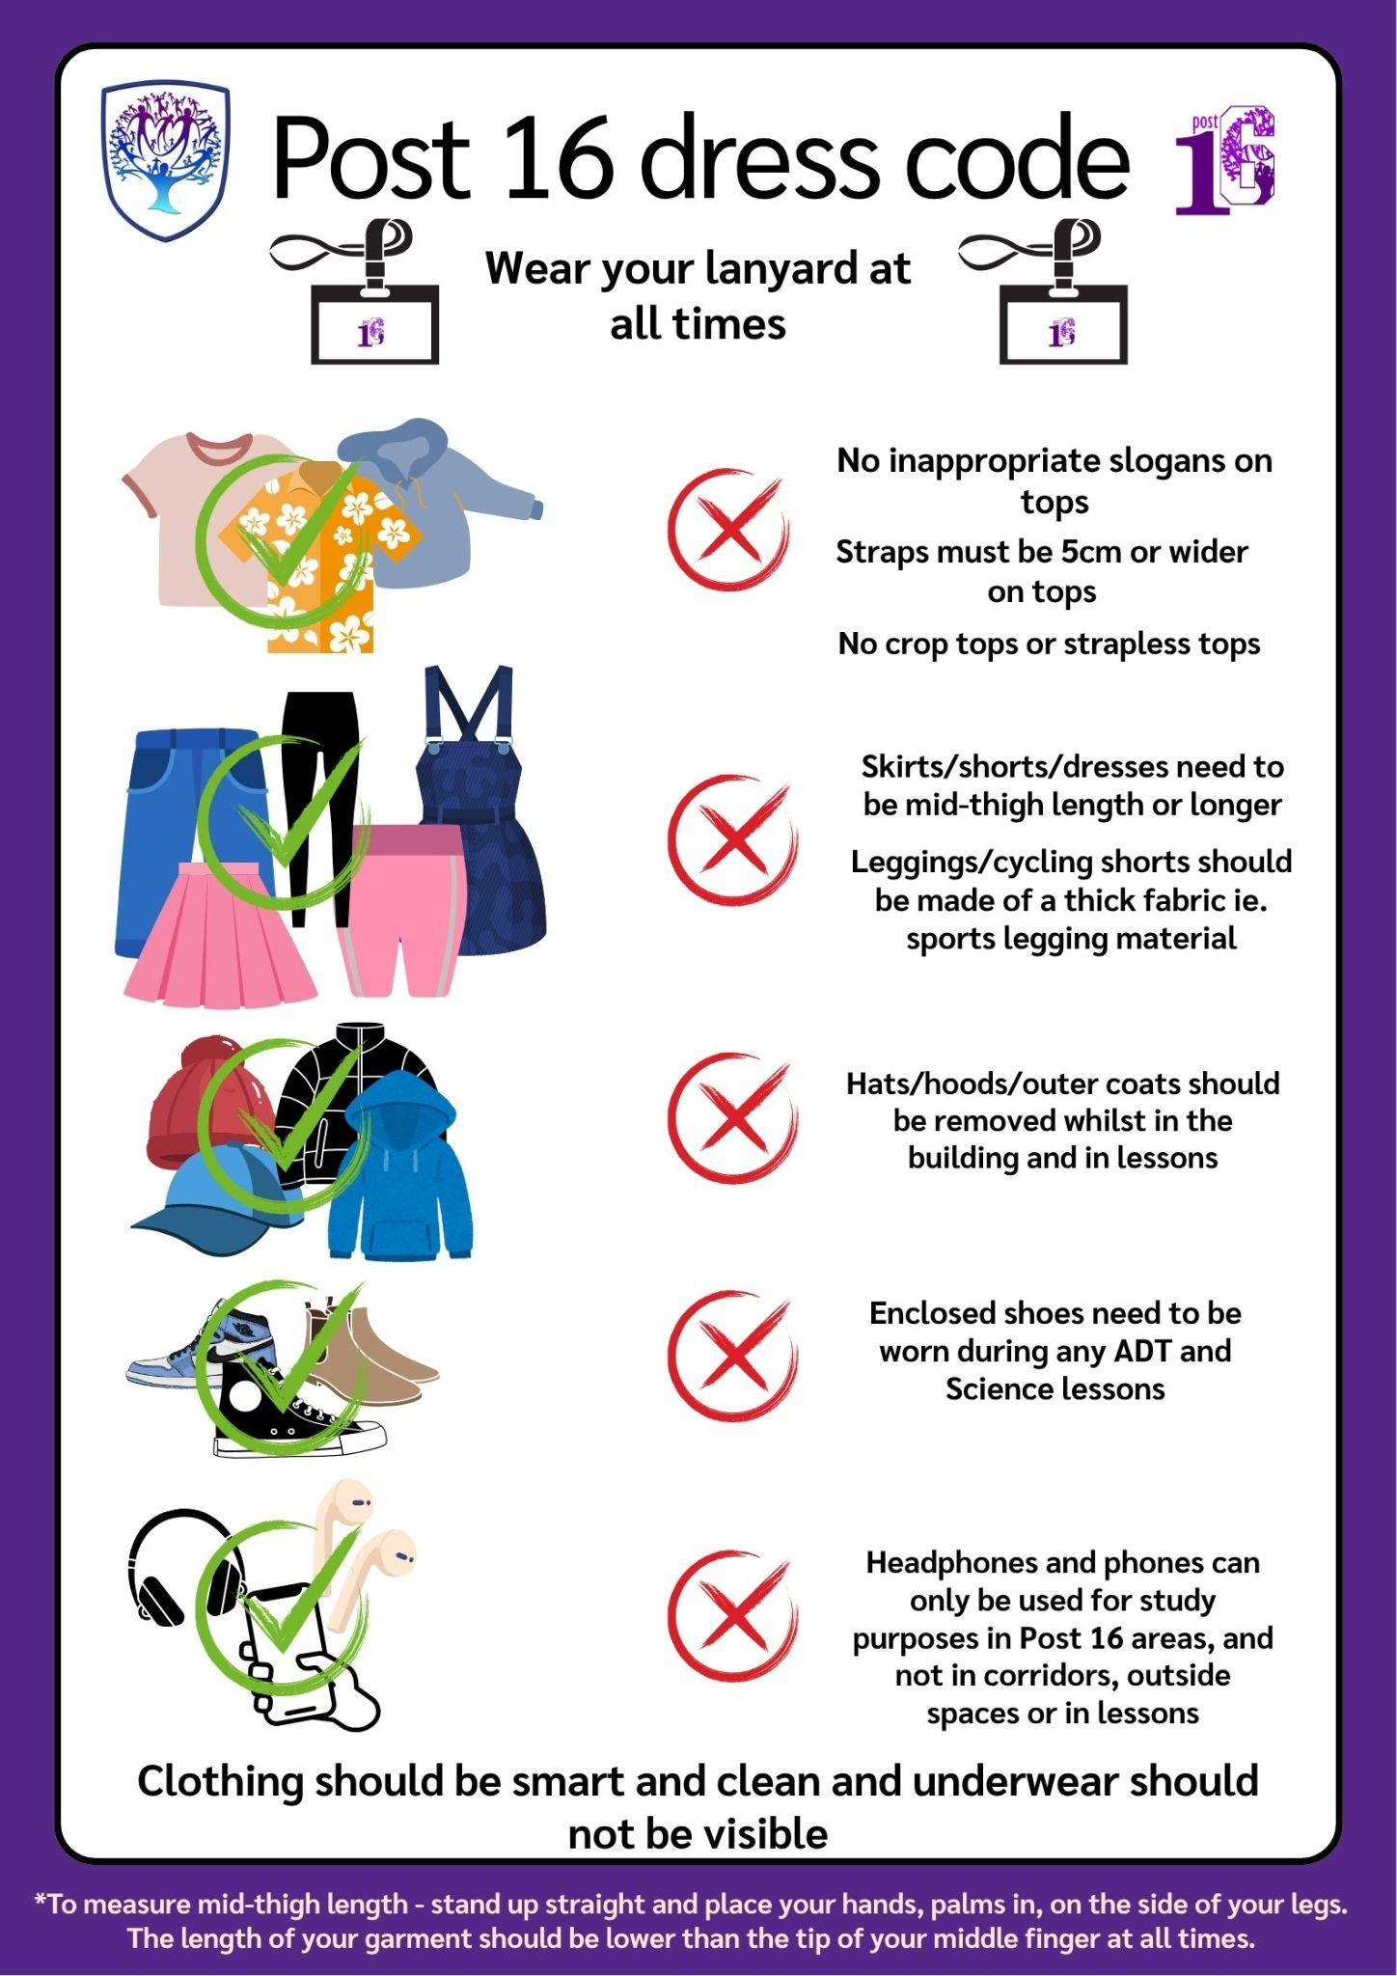

8. Post 16 Dress Code:
We believe that our Post 16 students should be seen as role models to the rest of the students on campus. We want to encourage our Post 16 students to be able to flourish and express their individuality, hence we do not have a designated uniform in the Post 16 Provision. This freedom dress is a privilege and therefore we have a Dress Code which we ask all Post 16 students to abide by at all times whilst on campus and travelling to and from the campus.

All students:
To adhere to the school’s Safeguarding Policy and to ensure the safety of all whilst on campus, lanyards must be worn and visible at all times.

