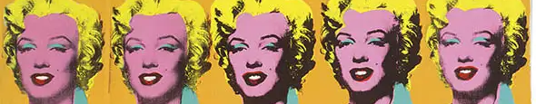


ART - Year 10 - (Summer Term)

Useful contacts / information  dlaw@brookvalegroby.com (Subject Lead and  Assistant Faculty Lead)    If you have any questions, please do not hesitate to contact your son/daughter’s subject teacher or the Subject Lead |  | What are we learning this term?  Topic 4: Portraits / Identity  In this extended unit, students will explore portraits and their own identity. They will carry out research based on a range of varied portrait artists' work and create a mood board based on the theme of their own identity. Critical and contextual work will work alongside the project to help inform ideas and experimental and development work. They will have the opportunity to work with a varied range of materials, techniques and processes throughout the project. They will also have the opportunity to explore and find their own influences that will later inform their initial ideas and ultimately a final design and personal response.

  Enrichment  Live Competitions posted on the Schools Social Media website for all students to get involved in.  ADT Enrichment Google Classroom created for students to experiment and create additional pieces of work for fun (these could be added into the Coursework Portfolio for additional marks/experimentation).    Extended Support available to support our students outside of lesson time with their work so that  they succeed in the  subject. |  | Homework  For homework, students’ are expected to complete weekly tasks, this work forms part of the portfolio and relates directly to what is being taught in class during that time. Each task is posted on the Google Classroom. It is expected that all students are staying in line with our academic year calendar when delivering homework. Students have access to Knowledge Organisers to support them with home learning. A subject drive has been created for all students so that they have access to relevant materials to help them at home. |  | Assessments  2. Gaudi - Skill Building Unit  3. Masks - Skill Building Unit  Please note that all work produced in Year 10 is part of the students coursework portfolio which equates to 60% of their overall grade for their GCSE qualification.  Students this term will receive an end of topic grade as well as an Overall Current Working Grade. This takes into consideration when the    students act on feedback  to improve their work.

‘Creativity takes courage’ - Henri Matisse

