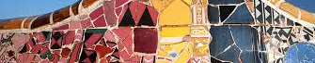
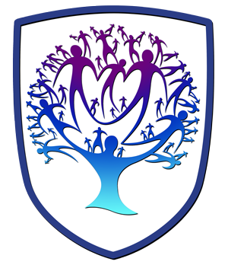

ART - Year 10 - (Spring Term)

Useful contacts / information  dlaw@brookvalegroby.com (Subject Lead and  Assistant Faculty Lead)    If you have any questions, please do not hesitate to contact your son/daughter’s subject teacher or the Subject Lead |  | What are we learning this term?  Topic 2: Gaudi  In this skill building unit, students will explore ‘Antoni Gaudi’s’ work. They will carry out research skills and create a moodboard influenced by Gaudi in the shape of a building. They will also source images associated with beach and sea life to assist  with design ideas. Initial ideas and a final design idea will be created in  colour. A personal response will then be created which will include use of  recycled materials, collage, relief and assemblage. Realistic observational  drawings will also form part of the project.  Topic 3: Masks  In this skill building unit, students will explore ‘Picasso’s’ work. They will carry out research skills and create a moodboard influenced by Picasso and masks from around the world. Initial ideas and a final design idea will be created in  colour using varied mediums. A personal response will then be created  which will include, paint, collage, relief and assemblage.  Realistic observational drawings will also form part of the project.

  Enrichment  Live Competitions posted on the Schools Social Media website for all students to get involved in.  ADT Enrichment Google Classroom created for students to experiment and create additional pieces of work for fun (these could be added into the Coursework Portfolio for additional marks/experimentation).    Extended Support available to support our students outside of lesson time with their work so that  they succeed in the  subject. |  | Homework  For homework, students’ are expected to complete weekly tasks, this work forms part of the portfolio and relates directly to what is being taught in class during that time. Each task is posted on the Google Classroom. It is expected that all students are staying in line with our academic year calendar when delivering homework. Students have access to Knowledge Organisers to support them with home learning. A subject drive has been created for all students so that they have access to relevant materials to help them at home. |  | Assessments  2. Gaudi - Skill Building Unit  3. Masks - Skill Building Unit  Please note that all work produced in Year 10 is part of the students coursework portfolio which equates to 60% of their overall grade for their GCSE qualification.  Students this term will receive an end of topic grade as well as an Overall Current Working Grade. This takes into consideration when the    students act on feedback  to improve their work.

‘Creativity takes courage’ - Henri Matisse

