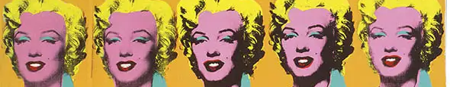


ART - Year 11 - (Spring Term)

Useful contacts / information  dlaw@brookvalegroby.com (Subject Lead and  Assistant Faculty Lead)  Smamo-curtis@brookvalegroby.  com  (Subject teacher)    If you have any questions, please do not hesitate to contact your son/daughter’s subject teacher or the Subject Lead |  | What are we learning this term?  Topic 2: Externally Set Assignment  In this unit of work, students will select one question from the exam paper - They will follow a similar journey as the extended project (Identity). Students’ will carry out artists research based on their chosen question, create transcriptions of the artists work and create a moodboard related to the theme/genre. Initial ideas will be created along with development work, which will lead to a final design. Each idea will be annotated to inform us of the students’ thought process and include information regarding the possible choice of materials, techniques and processes they could use. A final design will be created, which will lead to additional development work using a varied range of materials, techniques and processes, then ultimately a written action plan, alongside a mock-up of intentions. The students will then start the journey of creating a personal response which will be created under exam conditions over a two-day period. Students’ will mount-up their work and write-up an evaluation prior to the exam period.

  Enrichment  Live Competitions posted on the Schools Social Media website for all students to get involved in.  ADT Enrichment Google Classroom created for students to experiment and create additional pieces of work for fun (these could be added into the Coursework Portfolio for additional marks/experimentation).    Extended Support available to support our students outside of lesson time with their work so that  they succeed in the  subject. |  | Homework  For homework, students are expected to complete weekly tasks, this work forms part of the portfolio and relates directly to what is being taught in class during that time. Each task is posted on the Google Classroom. It is expected that all students are staying in line with our academic year calendar when delivering homework. Students have access to Knowledge Organisers to support them with home learning. A subject drive has been created for all students so that they have access to relevant materials to help them at home. |  | Assessments  3. Externally Set assignment  Please note that all the work produced in year 11 for the ‘Externally Set Assignment’ equates to 40% of their overall grade for their GCSE qualification.  Students this term will receive an end of topic grade as well as an Overall Current Working Grade. This takes into consideration when the    students act on feedback  to improve their work.

‘Art is anything you can get away with’ - Andy Warhol

