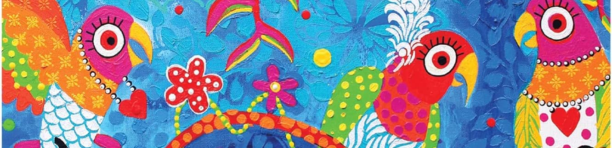


ART - Year 7 - Animals in Art (Autumn Term)


Useful contacts / information  dlaw@brookvalegroby-tmet.uk  (Subject Lead and  Assistant Faculty Lead)  Smamo-curtis@brookvalegroby-tmet.uk  (Subject Teacher)  If you have any questions, please do not hesitate to contact your son/daughter’s subject  teacher or the Subject Lead |  | What are we learning this term?  Rotations 1 & 2 (Weeks 1-16):  Students will engage in a project based around the theme ‘Animals in Art’ and produce a clay animal head towards the end of the rotation. They will explore the artwork of Henry Moore and Donna Sharman and create transcriptions based on the artists’ work. They will have the opportunity to create their own independent research on an animal of their choice and create a moodboard on this to support their design work. Students will create a design idea of an animal head, in preparation for clay work. Each individual will make their own unique design in clay learning about how to use clay safely and effectively. Once the clay has been fired, students will have the opportunity to paint their animal head  based on their designs influenced by the bright colourful work of  Donna Sharman and the mark making techniques of Henry Moore.



Enrichment  Live Competitions posted on the Schools Social Media website for all students to get involved in.  ADT Enrichment Google Classroom created for students to experiment and create additional pieces of work for fun. There are lots of choices for art students to be able to experiment with materials and techniques at home.  Other Enrichment opportunities will be advertised to the students  in the first term as these are  planned by ADT teachers. |  | Homework  Students will be given knowledge organiser homework alongside research activities to support the project and design work.  Students have access to Knowledge Organisers to support them with home learning (20:20:20).  A subject drive has been created for all students so that they have access to all materials to help  them at home. This is shared with students in lessons. |  | Assessments  1. Mid point of unit  2. End point of unit  Please note that students have one 2 hour lesson per week and are given a week to complete independent homeworks. This is why the students are assessed mid way and at the end of the rotations so that they can make progress over a series of 2 hour lessons in the unit of work.  Students are marked in relation to the unit checklist (personalised learning checklist). It is communicated if they are Exceeding, Meeting or  are Developing within the  subject.

‘Every child is an artist. The problem is how to remain an artist once we grow up.”
- Pablo Picasso

