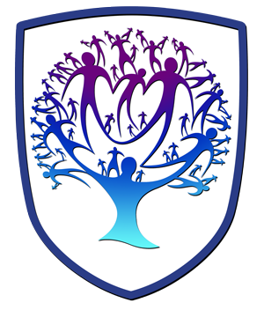
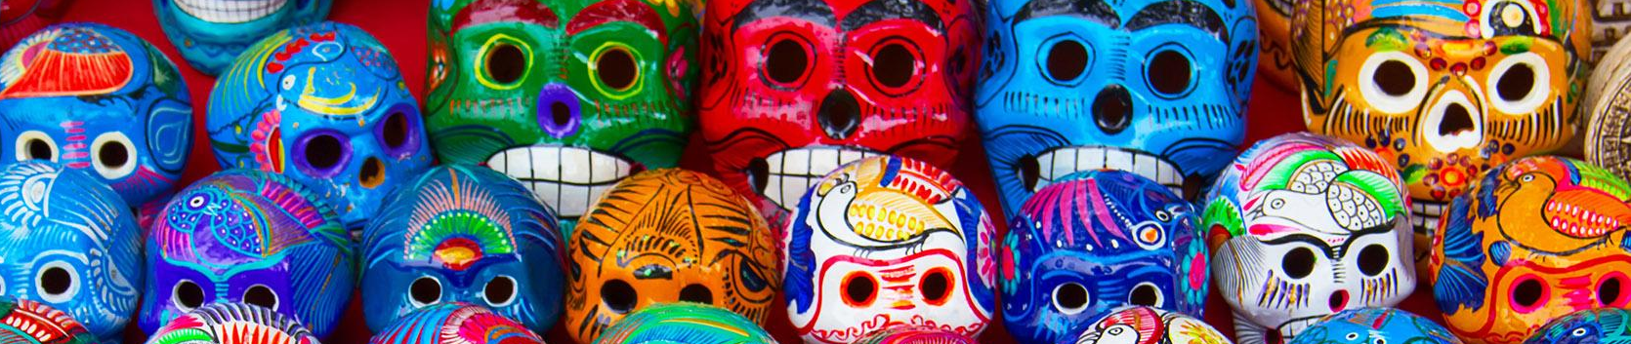

ART - Year 8 - Mexican Folk Art (Spring Term)


Useful contacts / information  dlaw@brookvalegroby.com  (Subject Lead and  Assistant Faculty Lead)  JSheeran@brookvalegroby.com  (Subject Teacher)  If you have any questions, please do not hesitate to contact your son/daughter’s subject  teacher or the Subject Lead |  | What are we learning this term?  Rotations 2 & 3 (Weeks 17-27):  Students will engage in a project based around the theme of ‘Mexican Folk Art’. They will develop their knowledge of the subject and carry out research in preparation for creating a moodboard, this will involve researching the types of images/artefacts they wish to look at for inspiration. Students’ will be taught the skills in observation drawing using the grid method and create a realistic tonal drawing. Following inspirations from the work created, they will create initial design ideas and a final design. This will lead to a more substantial piece of work in the form of a personal response, which will be created over a number of weeks. Students will be  encouraged to work with a range of varied materials, which  could include; paint, coloured pencil crayons, biro and collage  materials.



Enrichment  Live Competitions posted on the Schools Social Media website for all students to get involved in.  ADT Enrichment Google Classroom created for students to experiment and create additional pieces of work for fun. There are lots of choices for art students to be able to experiment with materials and techniques at home.  Other Enrichment opportunities will be advertised to the students  in the first term as these are  planned by ADT teachers. |  | Homework  Students will be given knowledge organiser homework alongside research activities to support the project and design work.  Students have access to Knowledge Organisers to support them with home learning (20:20:20).  A subject drive has been created for all students so that they have access to all materials to help  them at home. This is shared with students in lessons. |  | Assessments  1. Mid point of unit  2. End point of unit  Please note that students have one 2 hour lesson per week and are given a week to complete independent homeworks. This is why the students are assessed mid way and at the end of the rotations so that they can make progress over a series of 2 hour lessons in the unit of work.  Students are marked in relation to the unit checklist (personalised learning checklist). It is communicated if they are Exceeding, Meeting or  are Developing within the  subject.

‘I don’t paint dreams or nightmares, I paint my own reality' - Frida Kahlo

