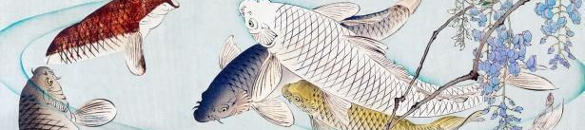


ART - Year 9 - Oriental Art (Spring Term)


Useful contacts / information  dlaw@brookvalegroby.com  (Subject Lead and  Assistant Faculty Lead)  Smamo-curtis@brookvalegroby.com  (Subject Teacher)  If you have any questions, please do not hesitate to contact your son/daughter’s subject  teacher or the Subject Lead |  | What are we learning this term?  Rotations 1 & 2 (Weeks 1-20):  In this skills building unit the students will look at traditional and contemporary Oriental Art from across various periods in history. They will complete image analysis and look closely at a variety of art sources and explore how they were created. They will create a moodboard showing influences on the theme and create realistic drawings from actual artefacts. This work is then used to create initial design ideas for the creation of a clay tile. A final design is then created to inform a personal response that will be made in clay - Clay safety forms part of the project. The clay work is then created, fired and painted.  Rotations 3 & 4 (Weeks 21-39):  In the second half of the project, students’ will work on producing an A3 mixed media art piece based on ‘Oriental art.’ They will recall the knowledge and the skills gained from the previous rotation and produce a personal response. Homeworks will also  form the basis of the creative process. Students will be encouraged to look  at a variety of materials and techniques to assist with the creation of the  end product.



Enrichment  Live Competitions posted on the Schools Social Media website for all students to get involved in.  ADT Enrichment Google Classroom created for students to experiment and create additional pieces of work for fun. There are lots of choices for art students to be able to experiment with materials at home.  Other Enrichment opportunities will be advertised to the students  in the first term as these are  planned by ADT teachers. |  | Homework  Students will be given an extended writing piece of homework alongside a number of research activities to support the ongoing design process.  Students have access to Knowledge Organisers to support them with home learning (20:20:20)  A subject drive has been created for all students so that they have access to all materials to help  them at home. This is shared with students in lessons. |  | Assessments  1. Mid point of unit (Rotations 1 & 3)  2. End point of unit (Rotations 1 & 3)  Please note that students have one 2 hour lesson per week and are given a week to complete independent homeworks. This is why the students are assessed mid way and at the end of the rotations so that they can make progress over a series of 2 hour lessons in the unit of work.  Students are marked in relation to the unit checklist (personalised learning checklist). It is communicated if they are Exceeding, Meeting or  are Developing within the  subject.

‘I like the fact that in ancient Chinese art the great painters always included a deliberate flaw in their work: human creation is never perfect..’ - Madeleine L'Engle

