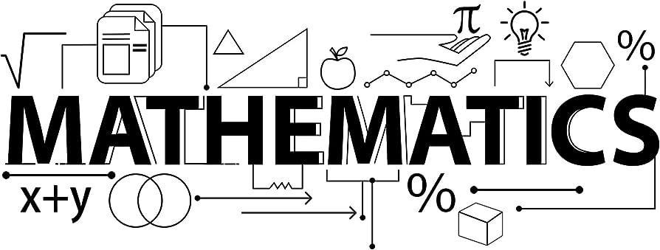


Mathematics Newsletter - Year 7 (Autumn Term)

Useful contacts / information  Paul McPherson - Faculty Leader  pmcpherson@brookvalegroby-tmet.uk  Stephen Taylor-Fox - Assistant Faculty Leader (Lead Teacher for Key Stage 3)    staylor-fox@brookvalegroby-tmet.uk |  | What are we learning this term?  During the Autumn term we will be covering the following topics:  - Sequences  - Understand and use algebraic notation  - Equality and equivalence  - Place value, ordering integers and decimals  - Fraction, decimal and percentage  equivalence  - Solving problems with addition &  subtraction  - Solving problems with multiplication &  division

Setting in Mathematics
Students have initially been set using their Key Stage 2 Mathematics scores. There are two sets for the most able (7R1/Ma and 7R2/Ma) and a set for those students requiring additional support (7S4/Ma). All other groups are mixed, middle ability groups.



Enrichment  Sparx Maths help club runs Monday, Tuesday,  Thursday and Friday lunchtimes (1:30pm-  1:50pm) in G03 |  | Homework  Homework is set every Tuesday on Sparx Maths |  | Assessments  The Autumn assessment will take place during the week commencing  Monday 17th  November

“Pure mathematics is, in its way, the poetry of logical ideas.” – Albert Einstein

