
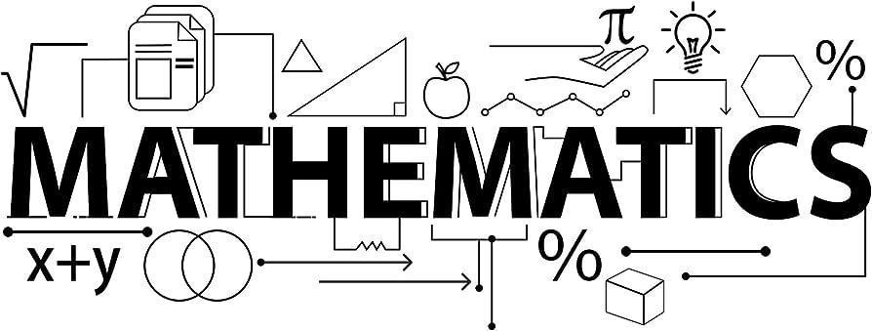

Mathematics Newsletter - Year 8 (Autumn term)

Useful contacts / information  Paul McPherson - Faculty Leader  pmcpherson@brookvalegroby-tmet.uk  Stephen Taylor-Fox - Assistant Faculty Leader (Lead Teacher for Key Stage 3)    staylor-fox@brookvalegroby-tmet.uk |  | What are we learning this term?  During the Autumn term we will be covering the following topics:  - Multiplying and dividing fractions  - Working in the Cartesian plane  - Representing data  - Tables and probability  - Brackets, equations & inequalities  - Sequences

Setting in Mathematics
Students have been set based on their Assessment scores throughout Year 7. There are two sets for the most able (8R1/Ma and 8R2/Ma) and a set for those students requiring additional support (8S4/Ma). All other groups are mixed, middle ability groups..



Enrichment  Sparx Maths help club runs Monday, Tuesday,  Thursday and Friday lunchtimes (1:30pm-  1:50pm) in G03 |  | Homework  Homework is set every Wednesday on Sparx Maths |  | Assessments  The Autumn assessment will take place during the week commencing  Monday 10th  November

“Pure mathematics is, in its way, the poetry of logical ideas.” – Albert Einstein

