
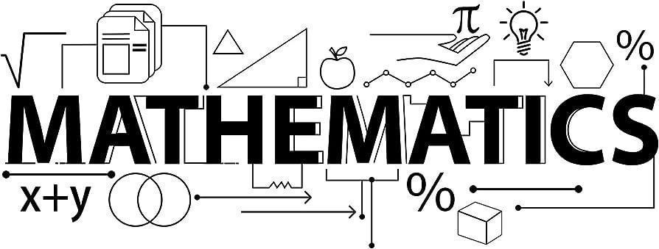

Mathematics Newsletter - Year 9 (Autumn term)

Useful contacts / information  Paul McPherson - Faculty Leader  pmcpherson@brookvalegroby-tmet.uk  Stephen Taylor-Fox - Assistant Faculty Leader (Lead Teacher for Key Stage 3)    staylor-fox@brookvalegroby-tmet.uk |  | What are we learning this term?  During the Autumn term we will be covering the following topics:  - Straight line graphs  - Forming and solving equations  - Testing conjectures  - 3D shapes  - Constructions and congruency  - Numbers  - Using percentages

Setting in Mathematics
Students have been set based on their Assessments throughout Year 8. We look at the setting following each term's Assessment to see if there are any students who are massively out of place.



Enrichment  Sparx Maths help club runs Monday, Tuesday,  Thursday and Friday lunchtimes (1:30pm-  1:50pm) in G03 |  | Homework  Homework is set every Wednesday on Sparx Maths |  | Assessments  The Autumn assessment will take place during the week commencing  Monday 17th  November

“Pure mathematics is, in its way, the poetry of logical ideas.” – Albert Einstein

