
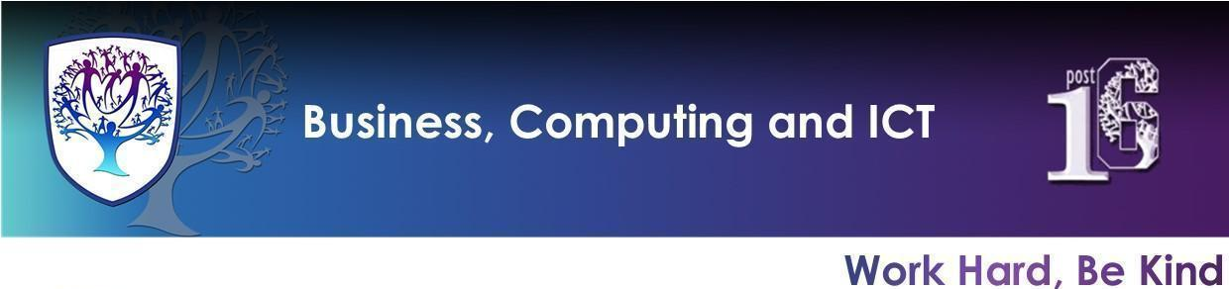

BCI - Year 10 - Business, Computer Science and Digital Information Technology (Autumn term)


Useful contacts / information  Mrs H Knight  hknight@hbrookvalegroby-tmet.uk  (BCI - Faculty Leader & Business Lead Teacher)  Mr I King  iking@brookvalegroby-tmet.uk  (ICT Lead Teacher)  Miss A Jackson  ajackson@brookvalegroby-tmet.uk  (Computer Science Lead Teacher)  If you have any questions, please do not hesitate to contact your child’s Business, Computer Science or IT Teacher, Subject Lead Teacher or Faculty Leader |  | What are we learning this term?  Students will be studying a range of topics please see a list below:  Business  Topic 1 Enterprise  Topic 2 Marketing  Computer Science  Algorithms ● Programming ● Pseudocode ● Flowcharts ●Binary ● Hexadecimal ● ASCII and Unicode ● Images ● Sound ● Compression ● Levels of programming ● Translators Storage ● Types of memory ● CPU  Digital Information Technology  Learning Aim A: Investigating Interface Design for Individuals and Organisations  Learning Aim B: Use Project Planning Techniques to Plan and Design a User Interface



Enrichment  Warhammer Club will run on a Friday after school and will run from 15:30-16:45 and is being led by iking@brookvalegroby-tmet.uk .  Scratch Coding Club, TBC.  Tycoon Enterprise competition will run during lunch time. More details to follow.  Other Enrichment opportunities will be advertised to students as these are  planned by BCI teachers. |  | Homework  A weekly knowledge organiser quiz will take place in class.  Students will also have a homework booklet which they will complete a section a week, this will be checked and marked during a lesson.  Students will use online platforms to embed learning. Business - Zig Zag, IT - Know it all Ninja.  Revision for each end of topic assessment with use of the knowledge organiser for the unit  and BBC Bitesize. |  | Assessments  Students will complete an end of topic assessment to check understanding and address any misconceptions. Please refer to the course calendars issued on the google classroom for specific dates of assessment.

Knowledge Organiser - Retrieval Learning
All KOs, links and homework documents are posted onto the Google Classroom but here are some quick links if you would also like to find them.
Business | Computer Science | Digital Information Technology
The tests are based on the issued knowledge organisers. | The tests are based on the following knowledge organisers.  Unit 1 Knowledge Organiser | The tests are based on the following knowledge organisers.  Component 1 Interfaces  Component 1 Planning Techniques

