
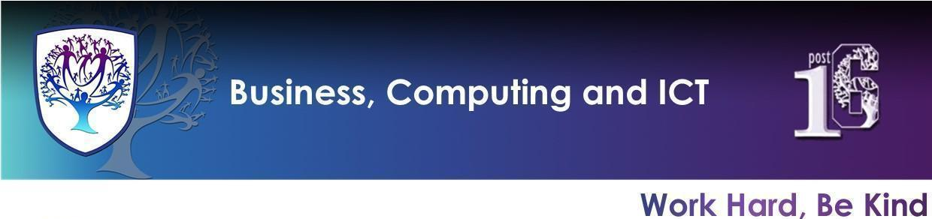

BCI - Year 11 - Business, Computer Science and Digital Information Technology (Autumn term)


Useful contacts / information  Mrs H Knight  hknight@hbrookvalegroby-tmet.uk  (BCI - Faculty Leader & Business Lead Teacher)  Mr I King  iking@brookvalegroby-tmet.uk  (ICT Lead Teacher)  Miss A Jackson  ajackson@brookvalegroby-tmet.uk  (Computer Science Lead Teacher)  If you have any questions, please do not hesitate to contact your child’s Business, Computer science and IT Teacher, Subject Lead Teacher or Faculty Leader |  | What are we learning this term?  Students will be studying a range of topics please see a list below:  Business  Topic 2.1 Growing the Business  Topic 2.2 Making marketing decisions  Computer Science  ● Open source and proprietary software ● Laws ● Ethical, legal, cultural, Environmental, and privacy issues ● Defensive design considerations ● Maintaining code ● Translators ● Levels of languages ● IDEs ●CPU and the Von Neumann architecture ● Primary and Secondary storage ● Embedded systems ●Binary, Hexadecimal ● ASCII and Unicode ● Images, Sound ● Compression ● Testing ● Programming practice  Digital Information Technology  Learning Aim A: Investigate the role and impact of using data on individuals and organisations  Learning Aim B:Create a Dashboard Using Data Manipulation Tools  Learning Aim C: Draw Conclusions and Review Data Presentation Methods  COMPONENT 2: Collecting Presenting and Interpreting Data (Coursework 30%)



Enrichment  Warhammer Club will run on a Friday after school and will run from 15:30-16:45 and is being led by iking@brookvalegroby-tmet.uk.  Scratch Coding Club, TBC.  Tycoon Enterprise competition will run during lunch time. More details to follow.  Other Enrichment opportunities will be advertised to students as these are  planned by BCI teachers. |  | Homework  A weekly knowledge organiser quiz will take place in class.  Students will also have a homework booklet which they will complete a section a week, this will be checked and marked during a lesson.  Students will use online platforms to embed learning. Business - Zig Zag, IT - Know it all Ninja.  Revision for each end of topic  assessment with use of the  knowledge organiser for the  unit and BBC Bitesize. |  | Assessments  Students will complete an end of topic assessment to check understanding and address any misconceptions. Please refer to the course calendars issued on the google classroom for specific dates of assessment.

Knowledge Organiser - Retrieval Learning
All KOs, links and homework documents are posted onto the Google Classroom but here are some quick links if you would also like to find them.
Business | Computer Science | Digital Information Technology
The tests are based on the following knowledge organisers.  Theme 2 Knowledge Organiser | The tests are based on the following knowledge organisers.  Component 2 Knowledge Organiser | The tests are based on the following knowledge organisers.  Component 3 Learning aim A  Component 3 Learning aim B  Component 3 Learning aim C

