
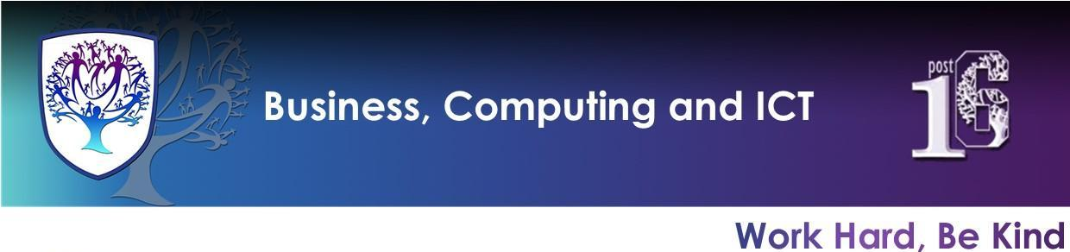

BCI - Year 8 - Computing (Autumn Term)


Useful contacts / information  Mrs H Knight  hknight@brookvalegroby-tmet.uk  (BCI - Faculty Leader)  Mr I King  iking@brookvalegroby-tmet.uk  (KS3 Computing Lead Teacher)  If you have any questions, please do not hesitate to contact your child’s Computing Teacher, Subject Lead Teacher or Faculty Leader |  | What are we learning this term?  Topic 1: Excel #1 Year 8 Computing Unit 1 - Spreadsheets KO.pdf  ●Entering data, and formatting  ●Mathematical functions  ●Chart creation and formatting  Preparing for use of spreadsheets in the workplace.  Provides skills on how to track and plan finances.  Topic 2: E-Safety #2 Year 8 Computing Unit 2 - Computing Ethics KO.pdf  ●How to use the internet and social media safely  ●Understanding laws  ●Good/bad use of personal data  Year 8 Computing Personalised Learning Checklist:  Year 8 Computing PLC.pdf  Digital Learning Resources:  https://www.bbc.co.uk/bitesize/guides/zdydmp3/revision/1  https://www.bbc.co.uk/bitesize/guides/zrtrd2p/revision/1  https://www.childline.org.uk/info-advice/bullying-abuse-safety/online-mobile-safety/

Enrichment  Warhammer Club will run on a Friday after school and is being led by Mr King - iking@brookvalegroby-tmet.uk.  Scratch Coding Club is being led by Mr King iking@brookvalegroby-tmet.uk. Start date TBC.  Other Enrichment opportunities will be advertised to the students  in the first term as these are    planned by BCI teachers. |  | Homework  A weekly knowledge organiser quiz will take place in class. Therefore, students must use their knowledge organisers to focus on subject specific terminology that links to the current unit of study. Students should practise learning key computing words by completing a choice of 3 tasks set in their Google Classroom each week (evidenced in their student planner).    Revision for each end of unit assessment with use of the knowledge organiser for the unit. |  | Assessments  1. Topic 1: Excel end of topic project  2. Topic 2: Ethics and E-Safety ongoing completion of Online Safety Certificate  Students are marked in relation to the unit checklist (personalised learning checklist). It is communicated if they are Exceeding, Meeting or  are Developing within the  subject during the term 1 reporting round.

