
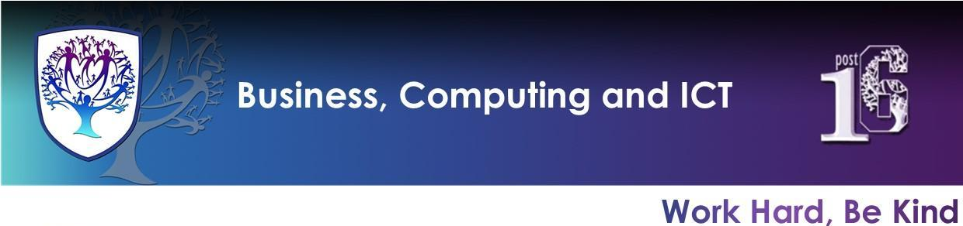

BCI - Year 7 - Computing (Autumn Term)


Useful contacts / information  Mrs H Knight  hknight@brookvalegroby-tmet.uk  (BCI - Faculty Leader)  Mr I King  iking@brookvalegroby-tmet.uk  (KS3 Computing Lead Teacher)  If you have any questions, please do not hesitate to contact your child’s Computing Teacher, Subject Lead Teacher or Faculty Leader |  | What are we learning this term?  Topic 1: Digital Literacy  Year 7 Computing KO Topic 1 - Digital Literacy.pdf  ●Basic computer skills  ●Computer shortcuts  ●File management  ●File type for images  ●Advanced search in google  Topic 2: PowerPoint & Hyperlinks  Year 7 Computing KO Topic 2.pdf  ●Powerpoint - design, formatting and animation  ●Powerpoint - transitions and hyperlinks  Year 7 Computing Personalised Learning Checklist:  Year 7 Computing PLC.pdf

Enrichment  Warhammer Club will run on a Friday after school and is being led by Mr King - iking@brookvalegroby-tmet.uk.  Scratch Coding Club is being led by Mr King iking@brookvalegroby-tmet.uk. Start date TBC.  Other Enrichment opportunities will be advertised to the students  in the first term as these are    planned by BCI teachers. |  | Homework  A weekly knowledge organiser quiz will take place in class. Therefore, students must use their knowledge organisers to focus on subject specific terminology that links to the current unit of study. Students should practise learning key computing words by completing a choice of 3 tasks set in their Google Classroom each week (evidenced in their student planner).    Revision for each end of unit assessment with use of the knowledge organiser for the unit. |  | Assessments  1. Topic 1: Digital Literacy end of unit google form assessment  2. Topic 2: PowerPoint & Hyperlinks end of topic project  Students are marked in relation to the unit checklist (personalised learning checklist). It is communicated if they are Exceeding, Meeting or  are Developing within the  subject during the term 1 reporting round.

