
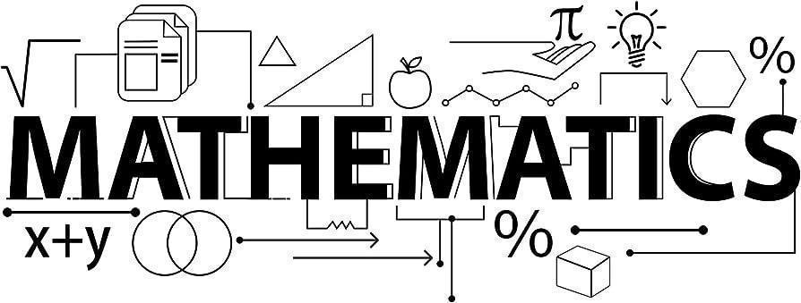

Mathematics Newsletter - Year 11 (Autumn term)

Useful contacts / information  Paul McPherson - Faculty Leader  pmcpherson@brookvalegroby-tmet.uk  Dan Kilduff - Assistant Faculty Leader (Lead Teacher for Key Stage 4)  dkilduff@brookvalegroby-tmet.uk    We would strongly advise all students to purchase a revision guide and workbook that are available from the school shop. |  | What are we learning this term?  During the Autumn term we will be covering the following topics:  - Non-calculator methods  - Types of number and sequences  - Indices and roots  - Manipulating expressions  - Gradients and lines  - Non-linear graphs  - Using graphs  - Expanding and factorising  - Changing the subject  - Functions  - Multiplicative reasoning  - Geometric reasoning  - Algebraic reasoning




Enrichment  Sparx Maths help club runs Monday, Tuesday,  Thursday and Friday lunchtimes (1:30pm-  1:50pm) in G03 |  | Homework  Homework is set every Thursday on Sparx Maths |  | Assessments  Autumn assessment weeks:  Weeks commencing  29th September  and 17th November  (mock exams)

“Pure mathematics is, in its way, the poetry of logical ideas.” – Albert Einstein

