
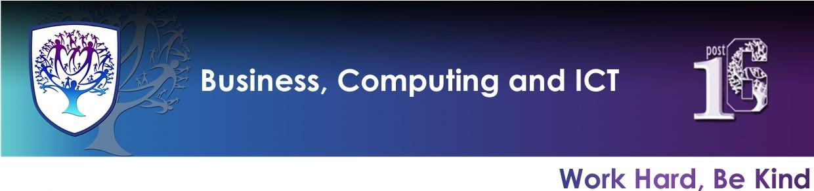

BCI - Year 9 - Computing (Spring/Summer Term)


Useful contacts / information  Mrs H Knight  hknight@brookvalegroby-tmet.uk  (BCI - Faculty Leader)  Mr I King  iking@brookvalegroby-tmet.uk  (KS3 Computing Lead Teacher)  If you have any questions, please do not hesitate to contact your child’s Computing Teacher, Subject Lead or Faculty Leader |  | What are we learning this term?  Topic 1: Digital Literacy  - Images and copyright  - Word processing skills  - Correct use of AI  - Email skills  - Desktop Publishing  Topic 2: Python Programming  - Printing  - Selection  - Integer Comparison  - Importing



Enrichment  Warhammer Club will run on a Friday after school and is being led by Mr King - iking@brookvalegroby-tmet.uk.  Scratch Coding Club is being led by Mr King iking@brookvalegroby-tmet.uk. Start date TBC.  Other Enrichment opportunities will be advertised to the students  in the first term as these are  planned by BCI teachers. |  | Homework  Students will be given knowledge organiser homework alongside research activities to support the project and design work.  Students have access to Knowledge Organisers to support them with home learning (20:20:20).  These have been created for all students so that they have access to all materials to help them at home. This is shared with students in lessons. |  | Assessments  1. Word Project  2. End point of unit (Multiple Choice test)

