
Geography - Year 7 - Unit 1
Geography and Me: An Introduction
Personal Learning Checklist

Use this checklist before your assessment to focus your work and after to check the effectiveness of your work.
G | I am confident about this topic and I know what I need to do.
A | I am not too sure about this topic. I may need to check with my teacher and spend more time working on this topic.
R | I am not confident I could answer a question on this topic. I need to check with my teacher and ensure I have what I need to do it.

 | Topic/Unit Focus
 |  | R | A | G
 | Locate on a map and label the 5 countries of the British Isles
 | Identify and locate human features from across the British Isles
 | Recognise some pictures and line symbols
 | Measure straight line distances and use the 4 main points of a compass
 | Draw a plan of an area/room from a birds eye view
 | Use basic scale measurements
 | Map and describe the physical and human features of my local area
 | Categorise topics into Human and physical Geography
 | Recognise most map symbols with and without a key
 | Locate symbols using 4 figure grid references
 | Use 8 or more points of a compass
 | Measure distances using different scales
 | Use my map reading skills in a range of situations
 | Explain how changing human pattern can influence landscapes and environments
 | Locate symbols confidently and accurately using 6 figure grid references
 | Ask geographical questions
 | Interpret place information from OS map, satellites, photographs and aerial photographs.

My targets moving forward:

Geography - Year 7 - Unit 2
Rivers and flooding
Personal Learning Checklist

Use this checklist before your assessment to focus your work and after to check the effectiveness of your work.
G | I am confident about this topic and I know what I need to do.
A | I am not too sure about this topic. I may need to check with my teacher and spend more time working on this topic.
R | I am not confident I could answer a question on this topic. I need to check with my teacher and ensure I have what I need to do it.

 | Topic/Unit Focus
 |  | R | A | G
 | I can describe the key processes of the water cycle (e.g., evaporation, precipitation, infiltration) and explain how water moves through it.
 | I can accurately define and label the key features of a drainage basin (e.g., source, mouth, tributary, watershed, flood plain).
 | I can locate the world's major glaciers and ice sheets on a map and explain the conditions needed for their formation.
 | I can explain the two main processes of glacial erosion (plucking and abrasion) and identify the resulting landforms (e.g., corries, U-shaped valleys).
 | I can describe the difference between the natural and enhanced greenhouse effect and identify the main greenhouse gases.
 | I can explain how human activity (like burning fossil fuels) causes global warming and leads to climate change.
 | I can make links between different geographical systems, such as how global warming can cause glaciers to melt and contribute to rising sea levels.
 | Suggest 'i can' statements that link to the learning in these lessons to create a personal learning checklist suitable for year 7 students, link to the national curriculum for geography, no more than 7 statemnets

My targets moving forward:

Geography - Year 7 - Unit 3
Africa; A continent of contrasts
Personal Learning Checklist

Use this checklist before your assessment to focus your work and after to check the effectiveness of your work.
G | I am confident about this topic and I know what I need to do.
A | I am not too sure about this topic. I may need to check with my teacher and spend more time working on this topic.
R | I am not confident I could answer a question on this topic. I need to check with my teacher and ensure I have what I need to do it.

 | Topic/Unit Focus
 |  | R | A | G
 | Identify and locate physical features from across Africa
 | Identify and locate human features from across Africa
 | Use basic map skills to read maps: scale, grid references, contour lines measurements
 | Describe patterns of Human Geography
 | Locate the continent of Africa
 | Map the physical and human features of Africa
 | Apply Map Skills to a range of situations
 | Describe the distribution of the physical and human features in environmental regions in Africa – with a focus on fair trade and cocoa farming
 | Compare the impacts and necessity of human activity on natural environments in Africa
 | Explain why the population of African regions may change over time
 | Describe the living conditions in shanty towns
 | Explain the problems with living in a shanty and methods used to improve them
 | Evaluate the potential impact of human activity on a local and global scale

My targets moving forward:

Geography - Year 8 - Unit 1
Natural Hazards
Personal Learning Checklist

Use this checklist before your assessment to focus your work and after to check the effectiveness of your work.
G | I am confident about this topic and I know what I need to do.
A | I am not too sure about this topic. I may need to check with my teacher and spend more time working on this topic.
R | I am not confident I could answer a question on this topic. I need to check with my teacher and ensure I have what I need to do it.

 | Topic/Unit Focus
 |  | R | A | G
 | Natural Hazards
 | - I can explain what a natural hazard is and give examples.
 | - I can describe the different types of natural hazards (tectonic and climatic).
 | Plate Tectonics
 | - I can explain the theory of plate tectonics.
 | - I can identify the global distribution of earthquakes and volcanoes and link this to plate boundaries.
 | - I can describe the processes that happen at different plate margins (destructive, constructive, conservative).
 | Earthquakes
 | - I can explain what causes earthquakes.
 | - I can describe the primary and secondary effects of earthquakes.
 | - I can explain the immediate and long-term responses to earthquakes.
 | - I can describe and explain a HIC (High-Income Country) earthquake case study.
 | - I can describe and explain a LIC (Low-Income Country) earthquake case study.
 | - I can compare the impacts and responses of earthquakes in HICs and LICs.
 | Reducing Risk
 | - I can explain how monitoring, prediction, protection, and planning can reduce the risk from tectonic hazards.
 | Weather Hazards
 | - I can describe different types of weather hazards in the UK.
 | - I can explain how tropical storms form.
 | - I can describe the causes, effects, and responses to a Typhoon.
 | - I can explain the causes and impacts of wildfires.

My targets moving forward:

Geography - Year 8 - Unit 2
Middle East
Personal Learning Checklist

Use this checklist before your assessment to focus your work and after to check the effectiveness of your work.
G | I am confident about this topic and I know what I need to do.
A | I am not too sure about this topic. I may need to check with my teacher and spend more time working on this topic.
R | I am not confident I could answer a question on this topic. I need to check with my teacher and ensure I have what I need to do it.

 | Topic/Unit Focus
 |  | R | A | G

My targets moving forward:

Geography - Year 8 - Unit 3
Global Issues
Personal Learning Checklist

Use this checklist before your assessment to focus your work and after to check the effectiveness of your work.
G | I am confident about this topic and I know what I need to do.
A | I am not too sure about this topic. I may need to check with my teacher and spend more time working on this topic.
R | I am not confident I could answer a question on this topic. I need to check with my teacher and ensure I have what I need to do it.

 | Topic/Unit Focus
 |  | R | A | G

My targets moving forward:

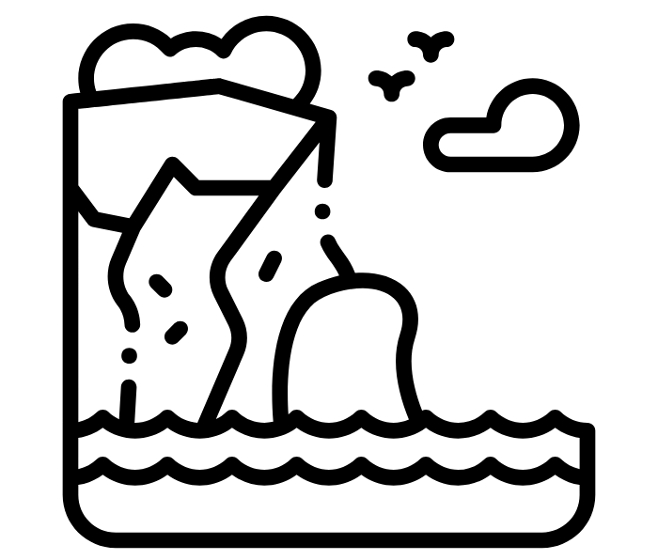
Topic: Physical landscapes in the UK - Coasts (Year 9)
Personal learning Checklist

Exam Board: AQA Paper: Paper 1 Section: C

Use this checklist before your assessment to focus your work and after to check the effectiveness of your work.
G | I am confident about this topic and I know what I need to do.
A | I am not too sure about this topic. I may need to check with my teacher and spend more time working on this topic.
R | I am not confident I could answer a question on this topic. I need to check with my teacher and ensure I have what I need to do it.

Week | Topic/Unit Focus | R | A | G
 | The coast is shaped by a number of physical processes
 | I know the different wave types and their characteristics.
 | I know the processes of coastal weathering, e.g. mechanical and chemical weathering.
 | I know the process of mass movement e.g. slumping, rock falls and landslides.
 | I know the processes of coastal erosion e.g. hydraulic action, abrasion, and attrition.
 | I know the processes of coastal transportation e.g. longshore drift.
 | I know the processes of coastal deposition and why sediment is deposited.
 | Distinctive coastal landforms are the result of rock type, structure, and physical processes
 | I understand how geological structure and rock type influence coastal forms.
 | I know the characteristics and formation of landforms resulting from erosion e.g. headlands and bays, cliffs and wave cut platforms, caves, arches, stacks, and stumps.
 | I know the characteristics and formation of landforms resulting from deposition e.g. spits, bars, beaches, and sand dunes.
 | I know a case study / example of a section of coastline in the UK to identify its major landforms of coastal erosion and deposition.
 | Different management strategies can be used to protect coastlines from the effects of physical processes
 | I know the costs and benefits of hard engineering e.g. sea walls, rock armour, gabions, and groynes.
 | I know the cost and benefits of soft engineering e.g. beach nourishment, reprofiling, and dune regeneration.
 | I know the coasts and benefits of managed retreat e.g. coastal realignment.
 | Case Study
 | I know a case study of an example of a coastal management scheme in the UK to show why management strategies are needed.
 | I know a case study of an example of a coastal management scheme in the UK to show the management strategies used.
 | I know a case study of an example of a coastal management scheme in the UK to show resulting effects and conflicts.

Therapy (Interventions)
Additional Support / Guidance

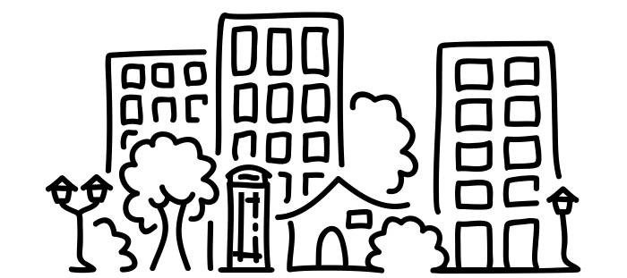
Topic: Urban Issues and Challenges
Personal learning Checklist

Exam Board: AQA Paper: Paper 2 Section: A

Use this checklist before your assessment to focus your work and after to check the effectiveness of your work.
G | I am confident about this topic and I know what I need to do.
A | I am not too sure about this topic. I may need to check with my teacher and spend more time working on this topic.
R | I am not confident I could answer a question on this topic. I need to check with my teacher and ensure I have what I need to do it.

Week | Topic/Unit Focus | R | A | G
 | A growing percentage of the world’s population lives in urban areas
 | I know the global pattern of urban change.
 | I understand urban trends in different parts of the world including HICs and LICs.
 | I can explain the factors affecting the rate of urbanisation – migration (push–pull theory), natural increase.
 | I can describe and explain the emergence of megacities.
 | Urban growth creates opportunities and challenges for cities in LICs and NEEs
 | I know a case study of a major city in an LIC or NEE to illustrate:
 | - the location and importance of the city, regionally, nationally, and internationally.
 | The causes of growth: natural increase and migration
- how urban growth has created opportunities:
- social: access to services – health and education; access to resources – water supply, energy.
- economic: how urban industrial areas can be a stimulus for economic development.
How urban growth has created challenges:
- managing urban growth – slums, squatter settlements
- providing clean water, sanitation systems and energy
- providing access to services – health and education
- reducing unemployment and crime
- managing environmental issues – waste disposal, air and water pollution, traffic congestion.
 | I know an example of how urban planning is improving the quality of life for the urban poor and can explain its main features
 | Urban change in cities in the UK leads to a variety of social, economic, and environmental opportunities and challenges.
 | Overview of the distribution of population and the major cities in the UK.
 | I know a case study of a major city in the UK to illustrate:
 | - the location and importance of the city in the UK and the wider world.
 | - the impacts of national and international migration on the growth and character of the city.
How urban change has created opportunities:
- social and economic: cultural mix, recreation and entertainment, employment, integrated transport systems
- environmental: urban greening
How urban change has created challenges:
- social and economic: urban deprivation, inequalities in housing, education, health, and employment.
- environmental: dereliction, building on brownfield and greenfield sites, waste disposal.
- the impact of urban sprawl on the rural–urban fringe, and the growth of commuter settlements.
I know an example of an urban regeneration project to show:
  - reasons why the area needed regeneration.
  - the main features of the project.
 | Urban sustainability requires management of resources and transport
I know the main features of sustainable urban living:
  - water and energy conservation
  - waste recycling
  - creating green space.
 | I can explain how urban transport strategies are used to reduce traffic congestion.

Therapy (Interventions)
Additional Support / Guidance

Geography - Year 9 - Unit 3
Map skills
Personal Learning Checklist

Use this checklist before your assessment to focus your work and after to check the effectiveness of your work.
G | I am confident about this topic and I know what I need to do.
A | I am not too sure about this topic. I may need to check with my teacher and spend more time working on this topic.
R | I am not confident I could answer a question on this topic. I need to check with my teacher and ensure I have what I need to do it.

 | Topic/Unit Focus
 |  | R | A | G
 | identify and locate physical features from across the British Isles
 | identify and locate physical features from across the world
 | draw a plan of an area/room from a bird’s eye view
 | use basic scale measurements
 | describe patterns of Human Geography
 | identify how these patterns have or may change over time
 | recognise most map symbols with and without a key
 | measure distances using different scales
 | start to ask geographical questions
 | locate symbols confidently and accurately using 6 figure grid references
 | see patterns between maps and satellite images (before and after images)
 | locate symbols confidently and accurately using 6 figure grid references
 | ask geographical questions and follow a sequence of enquiry
 | explain why patterns of human activity may or have changed over time
 | interpret place information from OS map, satellites, photographs and aerial photographs.
 | use GIS to view, analyse, answer questions, interpret places and data
 | draw conclusions using evidence collected to answer geographical questions

My targets moving forward:

