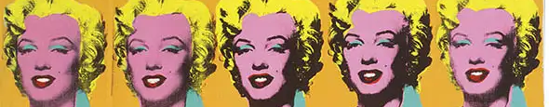
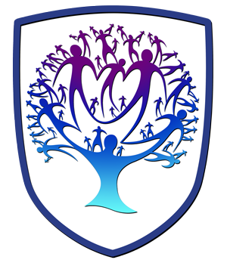

ART - Year 11 - (Autumn term)
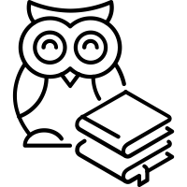
Useful contacts / information  dlaw@brookvalegroby-tmet.uk  (Subject Lead and  Assistant Faculty Lead)  Smamo-curtis@brookvalegroby-tmet.uk  (Subject teacher)    If you have any questions, please do not hesitate to contact your son/daughter’s subject teacher or the Subject Lead |  | What are we learning this term?  Topic 1: Identity  In this unit of work, students will work on a range of initial ideas. These ideas will then lead to a final design, further development work and an end product. To inform these ideas, students’ will use their mood boards, observation drawings, artistic influences and development work all created previously to create them. Each idea will be annotated to inform us of the students’ thought process and include information regarding the possible choice of materials, techniques and processes they could use. A final design will be created, which will lead to additional development work using a varied range of materials, techniques and processes, then ultimately an action plan written up, alongside a mock-up of intentions. The students’ will then start the journey of creating a personal response which will be created over a number of weeks. Students’ will then have the opportunity to mount-up all of the work for the extended project, of which will include annotations to reveal the journey from start to finish. A written evaluation will conclude this project. Students will have the opportunity to go back to previous satellite projects to  enhance or complete areas once the extended project is complete.

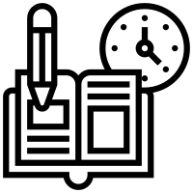  Enrichment  Live Competitions posted on the Schools Social Media website for all students to get involved in.  ADT Enrichment Google Classroom created for students to experiment and create additional pieces of work for fun (these could be added into the Coursework Portfolio for additional marks/experimentation).    Extended Support available to support our students outside of lesson time with their work so that  they succeed in the  subject. |  | Homework  For homework, students’ are expected to complete weekly tasks, this work forms part of the portfolio and relates directly to what is being taught in class during that time. Each task is posted on the Google Classroom. It is expected that all students are staying in line with our academic year calendar when delivering homework. Students have access to Knowledge Organisers to support them with home learning. A subject drive has been created for all students so that they have access to relevant materials to help them at home. |  | Assessments  1. Identity  2. Skill Building Units x 3  Please note that all work produced in Year 10 & 11 is part of the students coursework portfolio which equates to 60% of their overall grade for their GCSE qualification.  Students this term will receive an end of topic grade as well as an Overall Current Working Grade. This takes into consideration when the    students act on feedback  to improve their work.

‘Art is anything you can get away with’ - Andy Warhol

