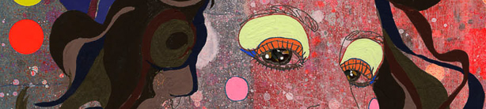


TEXTILES - Year 9 - (All Rotations)


Useful contacts / information  hdepledge@brookvalegroby-tmet.uk  (Subject Lead (textiles) and Assistant Faculty Lead)  smamo-curtis@brookvalegroby-tmet.uk  (Teacher of textiles)  If you have any questions, please do not hesitate to contact your son/daughter’s subject teacher or the Subject Lead |  | What are we learning this term?  Rotation 1: Analysing an Artist  In the first rotation students will further develop skills they have previously used whilst also learning about new ones. They will analyse the work of an artist and use this to create transcriptions (samples) made in their style using a variety of different techniques, using both hand and machine stitching  Rotation 2: Product Production  In the second rotation students will independently manufacture a product based around the artist they have researched, using the techniques they learnt and practised in the first rotation. They will decide on which skills and techniques they like and use these in the manufacture of a textile product, investigating how they can use the artist's work to create a unique product. Students will be encouraged to work as independently as possible whilst being creative and imaginative in their product manufacture.



Enrichment  Live Competitions posted on the Schools Social Media website for all students to get involved in.  ADT Enrichment Google Classroom created for students to experiment and create additional pieces of work for fun (these could be added into the Coursework Portfolio for additional marks/experimentation.  Extended Support available to support our students outside of lesson time with their design work so  that they succeed in the  subject. |  | Homework  For homework, students are expected to complete revision of their knowledge organisers by revising the relevant section for the week and self testing in their planners. The sections expected to be learnt are posted in the Google Classroom. In the following lesson students will be quizzed using their Do Now sheets in lessons.  Students have access to their Knowledge Organisers on the Google Classroom and if required can have a copy printed for them.  A subject drive has been created for all students so that they have access to all materials to help  them at home. |  | Assessments  Students will be assessed in two areas in year 9, their written work and their practical work.  Written work consists of designing and evaluating throughout the project.  Practical work consists of any experimentation work they produce as well as the manufacture of their final product.  Students will be assessed as either exceeding, meeting or developing in relation to their work.

‘Design is thinking made visual’ - Saul Bass

