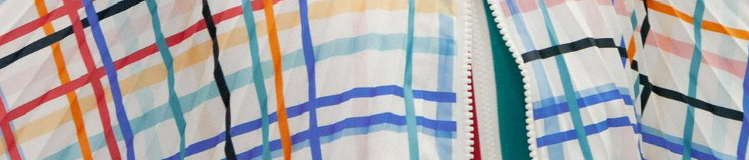


TEXTILES - Year 11 - (Autumn term)


Useful contacts / information  hdepledge@brookvalegroby-tmet.uk  (Subject Lead - Textiles and Assistant Faculty Lead)  cdepledge@brookvalegroby-tmet.uk  (Teacher of textiles)  If you have any questions, please do not hesitate to contact your son/daughter’s subject teacher or the Subject Lead |  | What are we learning this term?  In the autumn term students will be completing their Non-examined Assessment (NEA) which they began in year 10.  Students will be undertaking the following areas  - Design development - taking their initial ideas and developing them into better proposals for the design brief and statement of intent they have written  - Experimentation of ideas and techniques for the manufacture of their final design  - Final design idea produced  - Manufacture of a toile/mockup of their final piece  - Manufacture of their final design  - Evaluation of the project



Enrichment  Live Competitions posted on the Schools Social Media website for all students to get involved in.  ADT Enrichment Google Classroom created for students to experiment and create additional pieces of work for fun (these could be added into the Coursework Portfolio for additional marks/experimentation.  Extended Support available to support our students outside of lesson time with their design work so  that they succeed in the  subject. |  | Homework  For homework, students are expected to complete lesson tasks. These are posted in the Google Classroom. Each homework for our topics is different but it is expected that all students are staying in line with our academic year calendar.  Students have access to Knowledge Organisers to support them with home learning.  A subject drive has been created for all students so that they have access to all materials to help  them at home. |  | Assessments  Non-examined Assessment - regular feedback on strengths and targets for the project they have chosen to undertake  Please note that all work produced in Year 11 is part of the student’s coursework portfolio which equates to 60% of their overall grade for their GCSE qualification.  Students this term will receive a Current Working Grade. This takes into consideration the work the students have produced including  when the students act  on feedback  to improve their work.

Create your own style…let it be unique for yourself and yet identifiable for others”
Anna Wintour

