
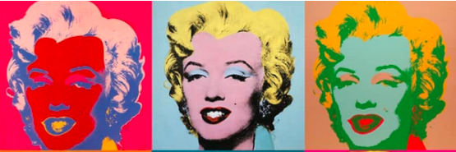
DESIGN - Year 11 - (Autumn term)


Useful contacts / information  cwright2@brookvalegroby.com  (Subject Lead)  If you have any questions, please do not hesitate to contact your son/daughter’s subject teacher or the Subject Lead |  | What are we learning this term?  Topic 1: R039 -COMMUNICATING DESIGNS -. Students will be completing this unit of work - Students will be using a topic set by the exam board (OCR) to design and model using CAD . The students will be creating design sheets based on the given theme and then fully develop the ideas. Students will refine the design and produce final engineering drawings to support the initial work. This will the be produced on the computers using Google Sketchup as a tool to create CAD drawings. The completed unit will be worth 30% of the final grade.  Topic 2: R038 REVISION FOR THE EXAM.  Revision for the exam (2026) will continue  throughout this half term during lessons, homeworks,  do now tasks and in the form of past papers being sat.



Enrichment  Live Competitions posted on the Schools Social Media website for all students to get involved in.  ADT Enrichment Google Classroom created for students to experiment and create additional pieces of work for fun (these could be added into the Coursework Portfolio for additional marks/experimentation.  Extended Support available to support our students outside of lesson time with their design work so  that they succeed in the  subject. |  | Homework  For homework, students are expected to complete lesson tasks. These are posted in the Google Classroom. Each homework for our topics are different but it is expected that all students are staying in line with our academic year calendar.  Students have access to Knowledge Organisers to support them with home learning.  A subject drive has been created for all students so that they have access to all materials to help  them at home.  DRIVE LINK |  | Assessments  1. R039 Communicating Design.  2.written final exam revision.  Please note that SOME work produced at the end of Year 10 is part of the students coursework portfolio which equates to 30% of their overall grade for their GCSE qualification.  Students this term will receive an end of topic grade as well as an Overall Current Working Grade. This takes into consideration when the  students act on feedback  to improve their work.

