
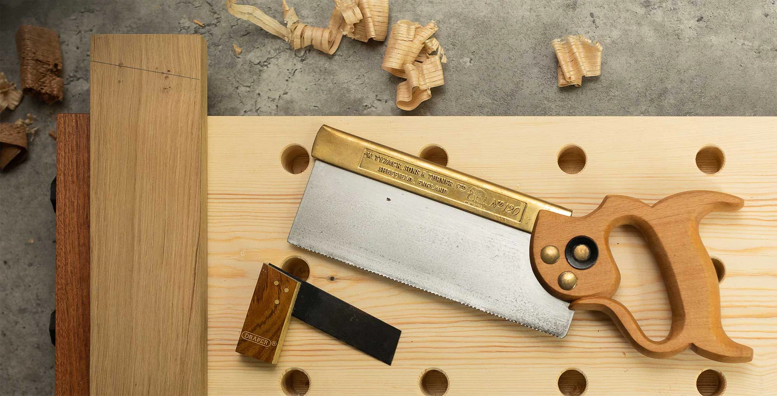

Design - Year 7 - Slottable Toy Project


Useful contacts / information  ctowers@brookvalegroby.com  cwright2@brookvalegroby.com  If you have any questions, please do not hesitate to contact your son/daughter’s subject teacher or the Subject Lead |  | What are we learning this term?  Year 7 complete a 9/ 10 week project which results in students making a wooden slottable toy from plywood. All lessons and supporting material are available on your child’s Google classroom.  Students learn how to:  Research wooden toys, produce moodboards and mindmaps, they analyse existing slottable toys, develop drawing skills, design and cardboard model their final idea, learn health and safety in the workshop, how to use tools and machinery correctly and how to evaluate their work. Students are usually in the  workshop completing practical work for approx 5  weeks until the project is finished.



Enrichment  Live Competitions posted on the Schools Social Media website for all students to get involved in.  ADT Enrichment Google Classroom created for students to experiment and create additional pieces of work for fun (these could be added into the Coursework Portfolio for additional marks/experimentation.  Extended Support available to support our students outside of lesson time with their design work so  that they succeed in the  subject. |  | Homework  For homework, students are expected to complete lesson tasks. These are posted in the Google Classroom. Each homework for our topics are different but it is expected that all students are staying in line with our academic year calendar.  Students have access to Knowledge Organisers to support them with home learning which we use for the Do Now tasks at the start of each lesson.  A subject drive has been created for all students so that they  have access to all materials  to help them at home. |  | Assessments  Students' work is assessed half way through the project and then at the end. Students are given ‘STAR TIME’ to read through their teachers feedback, understand the targets set and then improve their existing work.  At the end of the project both the practical work and the design folder and marks and targets are given. These are targets that students should be working on in their next art, design and technology area. Students will be given a summative grading  of developing, meeting  or exceeding.

"Design is not just what it looks like and feels like.
Design is how it works." - Steve Jobs, co-founder of Apple, Inc

