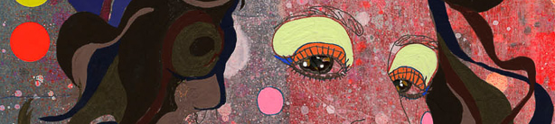


GRAPHICS - Year 10 - (Autumn term)


Useful contacts / information  Sdixon@brookvalegroby.com  (Subject Lead and Faculty Lead)  If you have any questions, please do not hesitate to contact your son/daughter’s subject teacher or the Subject Lead |  | What are we learning this term?  Topic 1: Patrick Boyer  In this skills building unit the students will look at the Graphic Designer/Illustrator, Patrick Boyer, and produce their own version of his work ‘Live on the Coke Side of Life’. The students will do this piece of work about themselves and their own likes and dislikes. This makes it a great first topic for the teacher to learn about the students that they will have over the course. In addition to this, students will be expected to critically analyse the artists work, produce some design ideas, take primary photographs and then compare their design work to that of the artists.  Topic 2: Sarah Beetson  In this skills building unit the students will look at another Graphic Designer/Illustrator. They will produce a front cover for a Magazine on a theme of their choice i.e Music. Students will look at the work ‘Ties Tops’ from the artist and how it has a deep meaning, they will produce exciting experimental backgrounds, produce digital illustrations and develop their work into a final front cover. They will compare their work  to the artists as a self reflection piece of writing at the end of the unit.  Topic 3: YEAR 9 STAR TIME SKILLS  This time enables the students to integrate some skills learnt from Year 9  into their coursework portfolio.



Enrichment  Live Competitions posted on the Schools Social Media website for all students to get involved in.  ADT Enrichment Google Classroom created for students to experiment and create additional pieces of work for fun (these could be added into the Coursework Portfolio for additional marks/experimentation.  Extended Support available to support our students outside of lesson time with their design work so  that they succeed in the  subject. |  | Homework  For homework, students are expected to complete lesson tasks. These are posted in the Google Classroom. Each homework for our topics are different but it is expected that all students are staying in line with our academic year calendar.  Students have access to Knowledge Organisers to support them with home learning.  A subject drive has been created for all students so that they have access to all materials to help  them at home. This is  shared with students in  lessons. |  | Assessments  1. Patrick Boyer Skill Building Unit  2. Sarah Beetson Skill Building Unit  3. Year 9 Skill Building Unit Work  Please note that all work produced in Year 10 is part of the students coursework portfolio which equates to 60% of their overall grade for their GCSE qualification.  Students this term will receive an end of topic grade as well as an Overall Current Working Grade. This takes into consideration when the  students act on feedback  to improve their work.

‘Design is thinking made visual’ - Saul Bass

