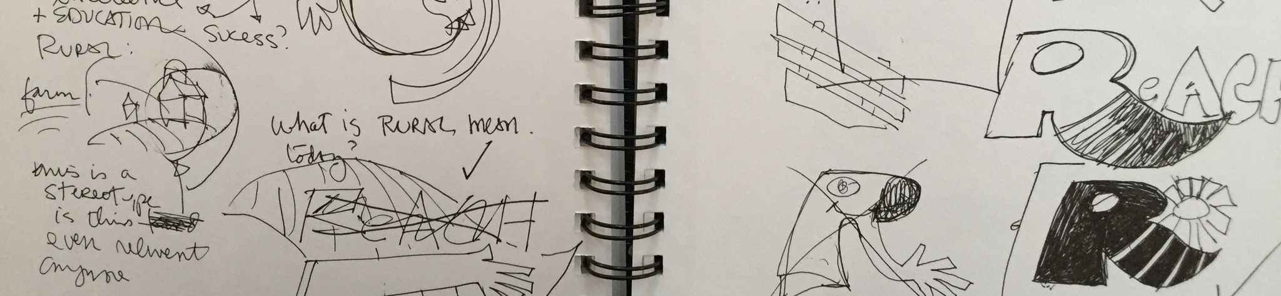
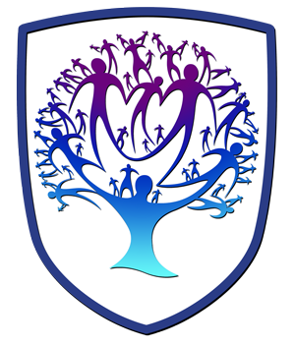

GRAPHICS - Year 10 - (Spring term)


Useful contacts / information  Sdixon@brookvalegroby.com (Subject Lead and Faculty Lead)  If you have any questions, please do not hesitate to contact your son/daughter’s subject teacher or the Subject Lead |  | What are we learning this term?  Topic 4: Logo Experimentation  In this skills building unit the students will look at producing and learning about more traditional skills such as Mono Printing and Polyboard Printing. Students will experiment with different artistic techniques and then use they traditional methods to work with digitally to form modern and unique Graphic products i.e a logo. The aim of this unit is to educate our students about how Graphic Designers do not rely on computer designs.  Topic 5: Design Idea Generation  In this skills building unit the students will produce mini briefs for themselves for outcomes such as Converse, CD Covers and Game Cover Design. Students will learn to communicate their ideas through sketches/drawing and annotation.  Topic 6: Personal Investigation  This unit of work sees the students starting their final major project. The students will start the project by mind mapping their own personal interests to identify  a theme. They will start initial research for their chosen theme by  producing moodboards, spider charts and writing potential ideas  for their project briefs. Students will be made aware that this project  will run till Christmas 2024 so they need to be happy with their choice  before writing a project brief.



Enrichment  Live Competitions posted on the Schools Social Media website for all students to get involved in.  ADT Enrichment Google Classroom created for students to experiment and create additional pieces of work for fun (these could be added into the Coursework Portfolio for additional marks/experimentation.  Extended Support available to support our students outside of lesson time with their design work so  that they succeed in the  subject. |  | Homework  For homework, students are expected to complete lesson tasks. These are posted in the Google Classroom. Each homework for our topics are different but it is expected that all students are staying in line with our academic year calendar.  Students have access to Knowledge Organisers to support them with home learning.  A subject drive has been created for all students so that they have access to all materials to help  them at home. This is  shared with students in  lessons. |  | Assessments  4. Experimentation Skill Building Unit  5. Design Idea Generation Skill Building Unit  6. Personal Investigation Unit  Please note that all work produced in Year 10 is part of the students coursework portfolio which equates to 60% of their overall grade for their GCSE qualification.  Students this term will receive an end of topic grade as well as an Overall Current Working Grade. This takes into consideration when the  students act on feedback  to improve their work.

‘Design is thinking made visual’ - Saul Bass

