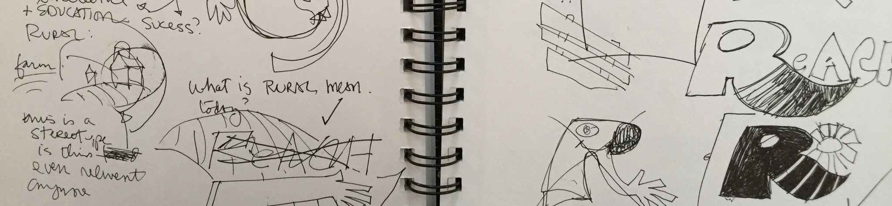


GRAPHICS - Year 10 - (Summer term)


Useful contacts / information  Sdixon@brookvalegroby.com (Subject Lead and Faculty Lead)  If you have any questions, please do not hesitate to contact your son/daughter’s subject teacher or the Subject Lead |  | What are we learning this term?  Topic 6: Personal Investigation  This unit of work sees the students continuing with their final major project. The students will start the project by mind mapping their own personal interests to identify a theme. They will start initial research for their chosen theme by producing moodboards, spider charts and writing potential ideas for their project briefs. Students will be made aware that this project will run till Christmas 2024 so they need to be happy with their choice  before writing a project brief.  Students will choose to look at artists and form their own responses to these for the theme of their project, they will look at colour theory, font analysis as well as analyse existing ideas for what it is that they will be producing for the project.  This term will see the students start to produce more work at home as it is vital that students complete work to a high standard and work must be completed  as part of homework.

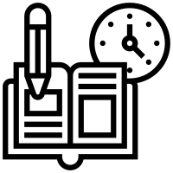

Enrichment  Live Competitions posted on the Schools Social Media website for all students to get involved in.  ADT Enrichment Google Classroom created for students to experiment and create additional pieces of work for fun (these could be added into the Coursework Portfolio for additional marks/experimentation.  Extended Support available to support our students outside of lesson time with their design work so  that they succeed in the  subject. |  | Homework  For homework, students are expected to complete lesson tasks. These are posted in the Google Classroom. Each homework for our topics are different but it is expected that all students are staying in line with our academic year calendar.  Students have access to Knowledge Organisers to support them with home learning.  A subject drive has been created for all students so that they have access to all materials to help  them at home. This is  shared with students in  lessons. |  | Assessments  4. Experimentation Skill Building Unit  5. Design Idea Generation Skill Building Unit  6. Personal Investigation Unit  Please note that all work produced in Year 10 is part of the students coursework portfolio which equates to 60% of their overall grade for their GCSE qualification.  Students this term will receive an end of topic grade as well as an Overall Current Working Grade. This takes into consideration when the  students act on feedback  to improve their work.

‘Design is thinking made visual’ - Saul Bass

