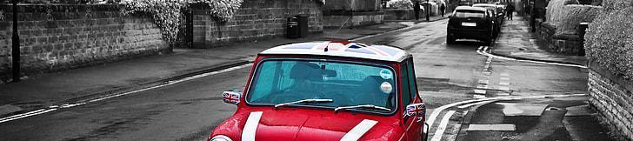


GRAPHICS - Year 9 - Skills Building


Useful contacts / information  Sdixon@brookvalegroby.com (Subject Lead and Faculty Lead)  Jsheerin@brookvalegroby.com  If you have any questions, please do not hesitate to contact your son/daughter’s subject  teacher or the  Subject Lead |  | What are we learning this term?  Rotation 1 & 2 (Weeks 1 - 10 / Weeks 11 - 20):  In this first rotation students will carry out three skills building units. The first unit will look at colour popping and how to digitally edit images effectively with this technique for Graphic Products such as magazines and CD Covers. The second unit will enable the students to develop digital drawing skills looking at the artist Lively Scout. The third skills building unit will look at the artist Ross Holden and how to digitally produce mandalas. Students will be assessed separately for all 3 units in this rotation.  Rotation 3 & 4 (Weeks 21 - 29 / Weeks 30 - 39):  In the second rotation we will work on Typography skills, learners will explore the possibilities that surround working with Typography in the Graphic Design world.  We will explore the use of typography when used in conjunction with paths tools.  Using text to shape subjects such as animals in reference to Bemboszoo.  Students will explore their own use of mixed media by creating their own  typography without the use of IT as a creative homework. By exploring all  of these techniques students will have the ability to further develop their  Photoshop skills ready for core GCSE modules.



Enrichment  Live Competitions posted on the Schools Social Media website for all students to get involved in.  ADT Enrichment Google Classroom created for students to experiment and create additional pieces of work for fun. There are lots of choices for Graphics students to be able to experiment with Photoshop at home.  Other Enrichment opportunities will be advertised to the students  in the first term as these are  planned by ADT teachers. |  | Homework  Students will be given practical homework in the first and second rotations. In the first rotation students will be asked to create handmade Mandalas inspired by Ross Holden. In the second rotation students will be asked to make hand made type. This affirms the importance of mixed media and experimentation outside of technology.  Students have access to Knowledge Organisers to support them with home learning (20:20:20)  A subject drive has been created for all students so that they have access to all materials to help  them at home. This is  shared with students in  lessons. |  | Assessments  1. 3 x Assessment points take place in Rotation 1  2. 3 x Assessment points take place in Rotation 2  Please note that in Graphics the first rotation sees the students complete 3 x mini skills building units and then in their next rotation they complete a larger skills building unit. This is why the assessments are structured the way that they are.  Students are marked in relation to the unit checklist (personalised learning checklist). It is communicated if they are Exceeding, Meeting or  are Developing within the  subject.

“Creativity is nothing but the way to solve new problems.” - Diana Santos

