
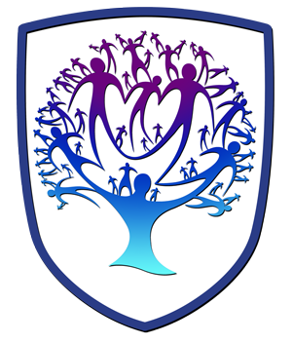

GRAPHICS - Year 11 - (Autumn Term)


Useful contacts / information  Sdixon@brookvalegroby.com (Subject Lead and Faculty Lead)  Jsheerin@brookvalegroby.com  If you have any questions, please do not hesitate to contact your son/daughter’s subject teacher or the Subject Lead |  | What are we learning this term?  Personal Investigation:  Completion of Research Unit (AO1 & AO3):  Students will be completing their coursework research section, and they will then summarise their research and produce a Design Specification for their personal project.  Beginning of Design Ideas & Development (AO2 & AO4):  During this section of work students will begin designing ideas for their x2 Outcomes for their personal investigation, using inspiration from their artist’s research.  For each Outcome (2 in total), they will be required to produce:  - x6 Sketched Design Ideas  - x4 Digital Design Ideas (using Photoshop)  - x1 Chosen Idea to Develop  - x6 slides of Design Development, addressing; colour, background, font style, blending options, layout, images & information.  STAR TIME:  Students will have STAR TIME built into their schedule to allow them to  catch-up with missed work and complete/improve their personal investigation.



Enrichment  Y11s will have Extended Support sessions available to help them to complete their coursework outside of lesson time so that they succeed in the subject. Sessions will be run at either lunchtimes and/or after school in G11.  Live Competitions posted on the School’s Social Media website for all students to get involved in.  ADT Enrichment Google Classroom created for students to experiment and create additional pieces of work for fun (these could be added into the Coursework Portfolio for additional marks/experimentation. |  | Homework  For homework, students are expected to complete coursework tasks started in the lesson. These are posted in the Google Classroom. Each student will have their own theme, therefore homeworks varies from student to student, but it is expected that all students are staying in line with the Y11 academic year calendar.  Students have access to Knowledge Organisers on Google Classroom to support them with home learning.  A subject drive has been created for all students so that they have access to all materials to help  them at home. This is  shared with students in  lessons. |  | Assessments  1. Research Unit (AO1 & AO3) - Colour Theory, Font Analysis, Questionnaire/Results and Design Specification.  2. Design Ideas & Development Unit (AO2 & AO4) - Sketched Ideas, Digital Ideas & Design Development.  Please note that all current work produced in Year 11 is part of the students coursework portfolio (Component 1) which equates to 60% of their overall grade for their GCSE qualification.  Students this term will receive an end of topic grade as well as an Overall Current Working Grade. This takes into consideration when the  students act on feedback  to improve their work.

‘Design is intelligence made visible’ - Alina Wheeler

