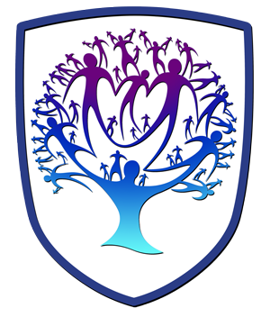
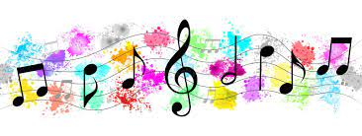


Music - Year 7
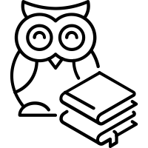

Useful contacts / information  To find out any information about our Music Curriculum or enrichment please contact  Laura Smith- Head of Performing Arts and Music subject Lead  lsmith@brookvalegroby-tmet.uk |  | What are we learning this term?  This term year 7 will be covering two topics. Our first topic will be looking at the Elements of Music. This topic focuses on all of the elements that make music what it is with activities focused on pitch, rhythm, melody etc.. The students will learn the acronym MAD T SHIRT where each letter represents a different element. This topic gives us the opportunity to see what the students already know and understand from their experiences from primary school.  We will then be moving on to looking at keyboard skills which will be the main instrument that students will use during KS3 to perform and compose. Students will be learning some notation basics, along with how to play a melody and simple chord progressions  We have also launched our singing curriculum where we aim to sing every lesson for 10 mins. We are starting with a song called ‘Baikeli’ which means Bicycle in Swahili. This is a song in two parts uses lots of chanting and call and response textures.


Enrichment  Music and Drama Clubs Autumn Term    Performances- Open Mic November  Christmas Concert December |  | Homework  Knowledge Organiser Quizzes  - Mad T Shirt (Elements of Music)  - Notation |  | Assessments  Baseline Assessment  Singing performances as a class  Classroom assessment of skills  Keyboard Performance

Music is a world within itself with a language we all understand
Stevie Wonder- Sir duke

