
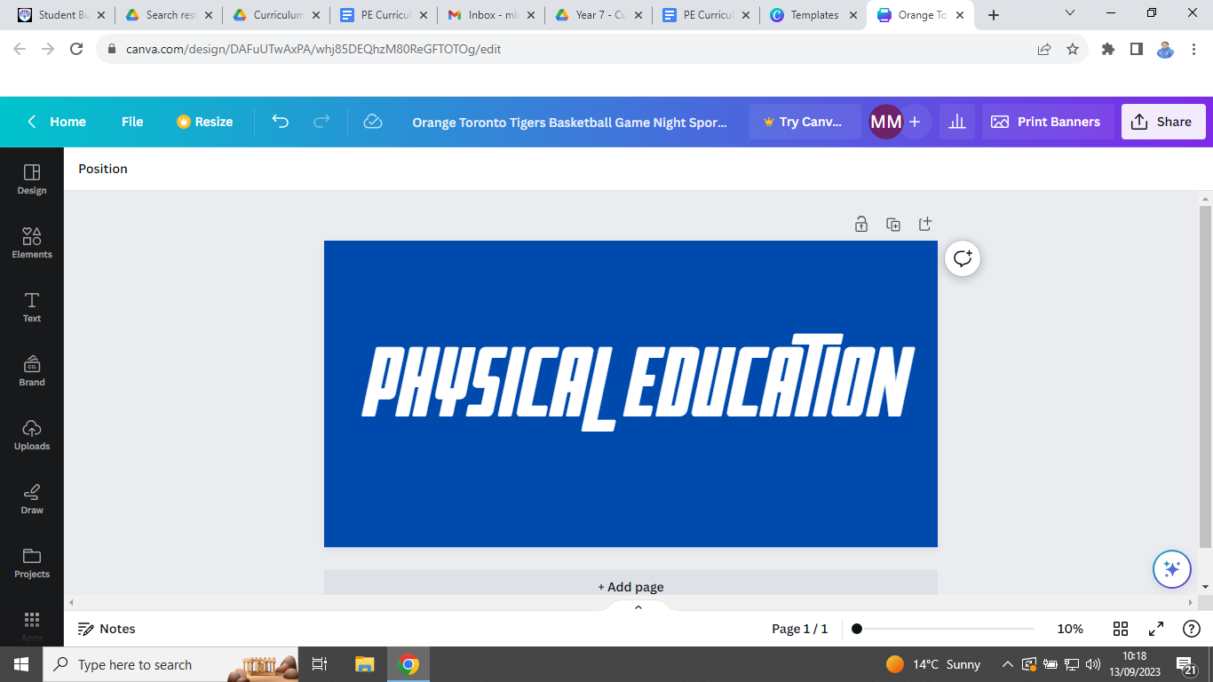


PE Curriculum Newsletter: Year 11 - Autumn Term


Useful contacts / information  Mr Brownett jbrownett@brookvalegroby.com  Mr Leonard  jleonard@brookvalegroby.com  Mr Lord - Curriculum Leader  mlord@brookvalegroby.com  Miss Maclachlan  amaclachlan@brookvalegroby.com  Mrs Richardson  mrichardson@brookvalegroby.com  Mr Sharpe  msharpe@brookvalegroby.com  Mrs Wiles - Head of KS3 PE  lwiles@brookvalegroby.com  For updates on Twitter/X:  @bglc_pe |  | What are we learning this term?  Core PE - students will be making their own decisions about activities that will study this year and will choose between either two or three options each half-term. During the Autumn term they will be have the option to participate in some of the following: football, golf, badminton, world games, capture the flag and exercise for health.  GCSE PE - in theory lessons students will have lessons on injury Sports Psychology, Injury Prevention, Components of Fitness, Principles of Training and Patterns of Physical Activity. In practical lessons the focus will be on badminton and netball. They will also be working on their AEP coursework task, involving a block of fitness testing and starting written coursework.  CNAT Sport Studies - the focus this month is  completing the R185 Leadership/Practical unit.  The deadline for submission is 21st November.



Enrichment  The following clubs are open to all Year 11 students. Activities will change again after October half-term, so look out for the new timetable then.  Basketball - Wednesday lunch time in the Groby Sports Hall.  Girls Netball - Thursday after school until 4:15pm. |  | Homework  Core PE - we don’t set homework for KS4 core PE.  GCSE PE - students will be expected to revise thoroughly for their unit tests and mock exams.  CNAT Sport Studies - students will be set homework relating to the submission of coursework for the two set deadlines. |  | Assessments  GCSE PE  Paper 2 Unit Test - wb 15/09/25  Mock Exams  Paper 1 Mock - wb 17/11/25  Paper 2 Mock - wb 24/11/25  CNAT Sport Studies  Deadlines:  R185 Coursework submission is 21st November 2025.

‘If you do not believe in yourself, no one will do it for you.’ Kobe Bryant

