
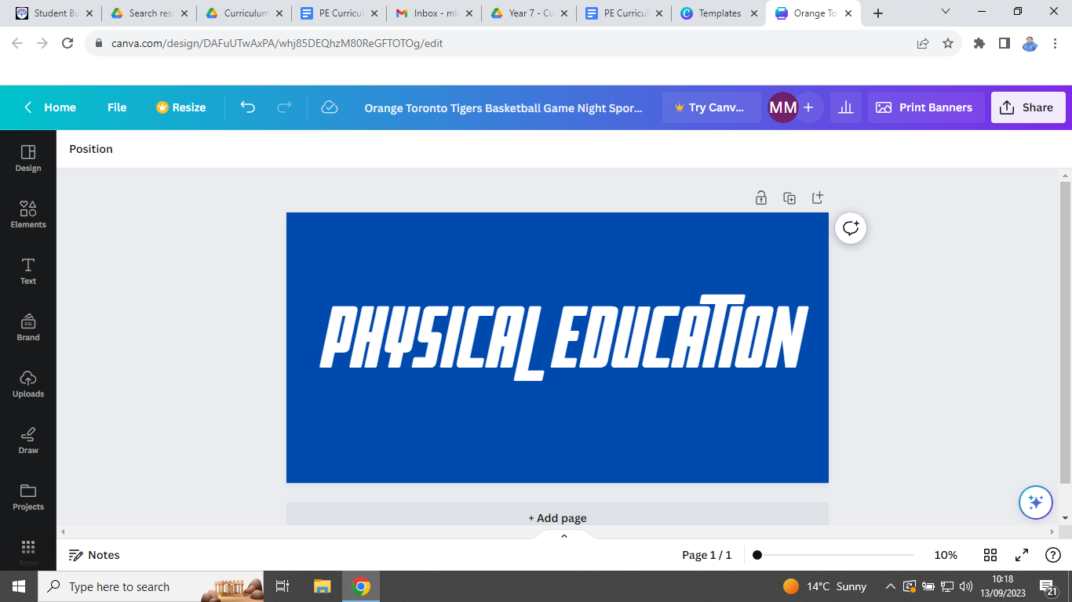


PE Curriculum Newsletter: Year 7


Useful contacts / information  Mr Brownett jbrownett@brookvalegroby.com  Mr Leonard  jleonard@brookvalegroby.com  Mr Lord - Curriculum Leader  mlord@brookvalegroby.com  Miss Maclachlan  amaclachlan@brookvalegroby.com  Mrs Richardson  mrichardson@brookvalegroby.com  Mr Sharpe  msharpe@brookvalegroby.com  Mrs Wiles - Head of KS3 PE  lwiles@brookvalegroby.com  For updates on Twitter/X:  @bglc_pe |  | What are we learning this term?  Students have two lessons a week and cover one particular activity for three weeks, so six lessons in total. Over the course of the Autumn term students in Year 7 will be covering some of the following activities: netball, football, basketball, gymnastics, Health Related Fitness, rugby and hockey.  Each lesson has a ‘Know, Grow, Show’ objective. The ‘Know’ objective links in with the rules and regulations of the activity, the ‘Grow’ objective focuses on LORIC values and the ‘Show’ objective links with skill and technique development.  We lose the Sports Hall in November for two weeks  due to Year 11 mock exams, so students will be  able to compete for their house in an activity of  their choosing during this period.



Enrichment  The following clubs are open to all Year 7 students. Activities will change again after October half-term, so look out for the new timetable then.  Basketball - Wednesday lunch time in the Groby Sports Hall.  Girls Netball - Tuesday after school until 4:15pm.  Football - Boys on a Wednesdat and Girls on a Thursday after school until 4:15pm. |  | Homework  Each student will have a rules quiz to complete for homework at the end of each activity block of 6 lessons. These rules quizzes are posted on each group’s Google Classroom and are completed digitally using Google Forms. The results from these quizzes allow us to assess students under the ‘Know’ strand of our assessment policy. |  | Assessments  We assess students in PE at the end of each activity block. We assess them in three areas:  ‘Know’ - knowledge of rules and regulations.  ‘Grow’ - demonstrating LORIC character values.  ‘Show’ - the ability to perform activity specific skills and tactics under competitive pressure.

‘I’ve failed over and over and over again in my life and that is why I succeed.’
Michael Jordan

