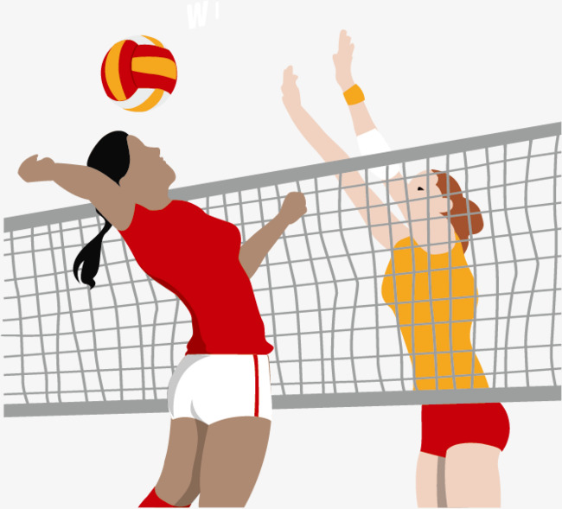
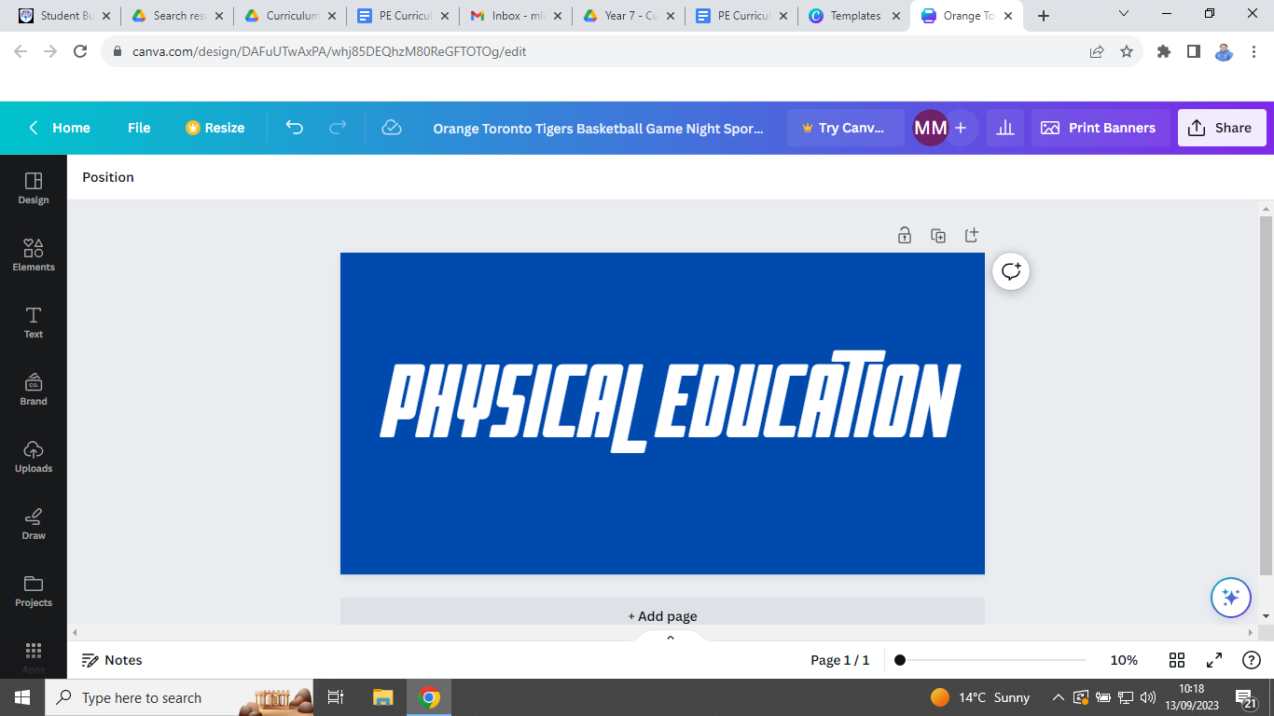


PE Curriculum Newsletter: Year 9 - Autumn Term


Useful contacts / information  Mr Brownett jbrownett@brookvalegroby.com  Mr Leonard  jleonard@brookvalegroby.com  Mr Lord - Curriculum Leader  mlord@brookvalegroby.com  Miss Maclachlan  amaclachlan@brookvalegroby.com  Mrs Richardson  mrichardson@brookvalegroby.com  Mrs Sharpe  msharpe@brookvalegroby.com  Mrs Wiles - Head of KS3 PE  lwiles@brookvalegroby.com  For updates on Twitter/X:  @bglc_pe |  | What are we learning this term?  Students have chosen their teaching groups this year and have opted into either a GCSE PE/CNAT Sport preparation group, a creative activities group or a games group. Over the course of the Autumn term, depending on the group they are in, students will cover some of the following activities: hockey, netball, football, fitness testing, badminton, orienteering, dance, cricket, table tennis, volleyball, basketball and Health Related Fitness.  We lose the Sports Hall in November for two weeks due to Year 11 mock exams, so students will be able to compete for  their house in an activity of their choosing during  this period.



Enrichment  The following clubs are open to all Year 9 students. Activities will change again after October half-term, so look out for the new timetable then.  Basketball - Wednesday lunch time in the Groby Sports Hall.  Girls Netball - Tuesday after school until 4:15pm.  Football - Boys on a Wednesday and Girls on a Thursday after school until 4:15pm. |  | Homework  Each student will have a rules quiz to complete for homework at the end of each activity block of 6 lessons. These rules quizzes are posted on each group’s Google Classroom and are completed digitally using Google Forms. The results from these quizzes allow us to assess students under the ‘Know’ strand of our assessment policy. |  | Assessments  We assess students in PE at the end of each activity block. We assess them in three areas:  ‘Know’ - knowledge of rules and regulations.  ‘Grow’ - demonstrating LORIC character values.  ‘Show’ - the ability to perform activity specific skills and tactics under competitive pressure.

‘If my mind can conceive it and my heart can believe it - then I can achieve it’
Muhammad Ali

