Complete these PLCs to track your progress with reading and writing skills.Think about your work in class, your homework booklets and assessments. Are you using these skills regularly and correctly?
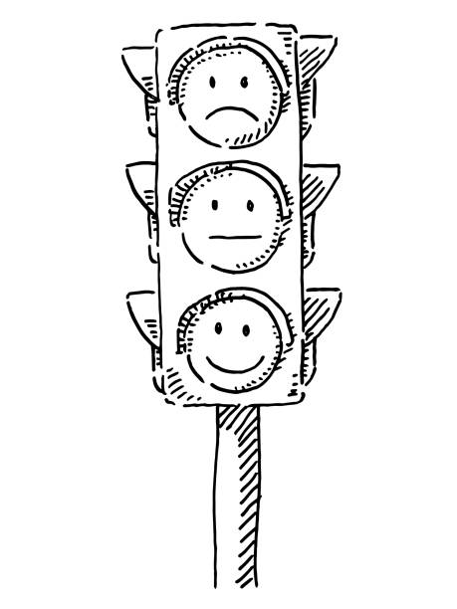

R = Red. I am not confident with this skill, do not use it regularly and often need help.
A = Amber. I am fairly confident with this skill, sometimes use this in my writing, and sometimes need help.
G = Green. I am very confident with this skill, use it regularly and correctly in my writing and rarely need help.

PLC 1 - Autumn Term: Benchmark audit | R | A | G
I can pick out key information from a text to plan a question response
I can embed appropriate quotations in my discussion
I can use discourse markers to structure my discussion
I can identify writer's methods and discuss them in my writing
I can give a personal response to a text
I can say two or more things about a moment in a text
I understand that context can be important when writing a response
I can stay in the same tense and perspective when I write creatively
I can use varied punctuation, and varied sentence types when I write
I can use varied and sophisticated vocabulary when I write

PLC2 - Literature | R | A | G
I know the plot and characters in 'Animal Farm'
I know the text is an allegory for the Stalin era Soviet Union
I know at least 7 key words relevant to this text (eg. tyranny)
I can pick out key information from a text to plan a question response
I can embed appropriate quotations in my discussion
I can use discourse markers to structure my discussion
I can identify writer's methods and discuss them in my writing
I can give a personal response to a text
I can say two or more things about a moment in a text
I understand that context can be important when writing a response
I can use a range of vocabulary to help express my ideas.

PLC 3 - Writing to be Heard | R | A | G
I can shape my ideas into a cohesive and coherent piece of writing
I can use ethos, logos and pathos in my writing
I can use at least 3 other rhetorical devices in my persuasive writing
I can use varied, sophisticated, vocabulary to engage my audience
I can vary my sentence types to keep my audience engaged
I can speak clearly and confidently, and vary my tone and pace

PLC 4 - end of year audit | R | A | G
Language: Reading
I can pick out key information to answer multiple choice questions
I can discuss how the writer uses language to do something specific
I can discuss how the writer structures a text to do something specific
I can give my opinion, and evaluate a text
Language: Writing
I can stay in the same tense and perspective when I write creatively
I can use varied punctuation, and varied sentence types when I write
I can use varied and sophisticated vocabulary when I write
Literature
I can pick out key information from a text to plan a question response
I can embed appropriate quotations in my discussion
I can use discourse markers to structure my discussion
I can identify writer's methods and discuss them in my writing
I can give a personal response to a text
I can say two or more things about a moment in a text
I understand that context can be important when writing a response
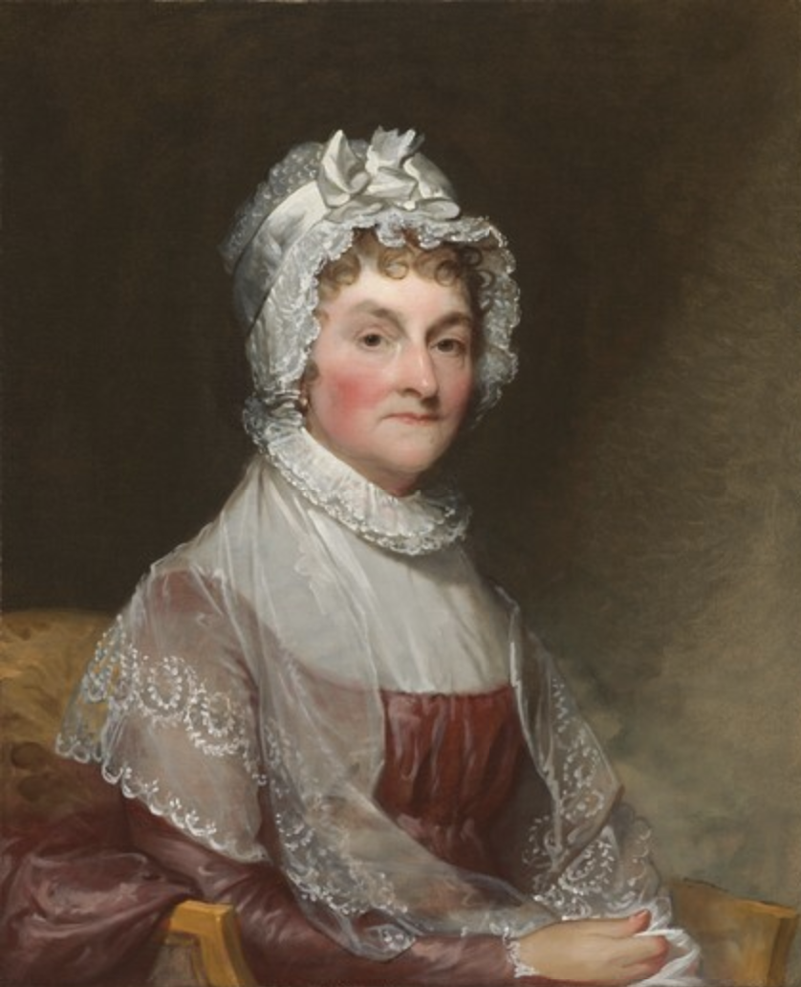

Learning is not attained by chance, it must be sought for with ardor and diligence.
- Abigail Adams (1744-1818) American First Lady; wife of the second President of the United States (John Adams), and mother of the sixth (John Quincy Adams)

