Complete these PLCs to track your progress with reading and writing skills.Think about your work in class, your homework booklets and assessments. Are you using these skills regularly and correctly?
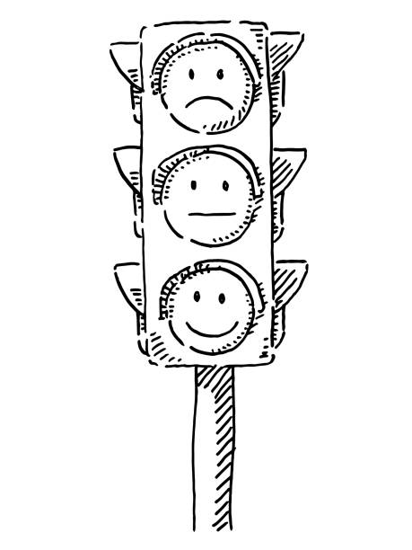

R = Red. I am not confident with this skill, do not use it regularly and often need help.
A = Amber. I am fairly confident with this skill, sometimes use this in my writing, and sometimes need help.
G = Green. I am very confident with this skill, use it regularly and correctly in my writing and rarely need help.

PLC 1 - Autumn Term: Benchmark audit | R | A | G
I can pick out key information from a text to plan a question response
I can embed appropriate quotations in my discussion
I can use discourse markers to structure my discussion
I can identify writer's methods and discuss them in my writing
I can give a personal response to a text
I can say two or more things about a moment in a text
I understand that context can be important when writing a response
I can stay in the same tense and perspective when I write creatively
I can use varied punctuation, and varied sentence types when I write
I can use varied and sophisticated vocabulary when I write

PLC2 - Literature | R | A | G
I know the plot and characters in MB, ACC, AF
I know at least 7 key words relevant to each text
I can pick out key information from a text to plan a question response
I can discuss what the writer is doing, how, and why
I can embed appropriate quotations in my discussion
I can use discourse markers to structure my discussion
I can use appropriate subject terminology (tier 3 vocabulary)
I can give a personal response to a text
I can say two or more things about a moment in a text
I understand that context can be important when writing a response
I can use a range of vocabulary to help express my ideas.

PLC 3 - Poetry | R | A | G
I can discuss the writer's big idea in each anthology poem
I can link poems together through themes and ideas
I can use appropriate subject terminology (tier 3 vocabulary) for poetry
I can use discourse markers to structure my discussion
I can give a personal response to a poem
I can say two or more things about a moment in a text
I understand that context can be important when writing a response
I can use a range of vocabulary to help express my ideas

PLC 4 - pre-exams audit | R | A | G
Language: Reading
I can pick out key information from an unseen text
I can summarise details from a text / texts
I can discuss how the writer uses language to do something specific
I can discuss how the writer structures a text to do something specific
I can give my opinion, evaluate, and compare texts
Language: Writing
I can stay in the same tense and perspective when I write
I understand the importance of identifying audience, form, and purpose
I can use varied punctuation, and varied sentence types when I write
I can use varied and sophisticated vocabulary when I write
Literature
I can pick out key information from a text to plan a question response
I can embed appropriate quotations in my discussion
I can use discourse markers to structure my discussion
I can identify writer's methods and discuss them in my writing
I can give a personal response to a text
I can say two or more things about a moment in a text
I understand that context can be important when writing a response

