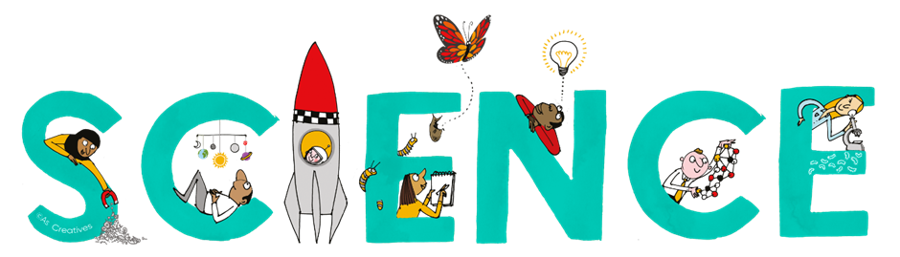


Subject Newsletter - Year 11 - (Autumn term)

Useful contacts / information  Helen Hawke - Faculty Leader  hhawke@brookvalegroby.com  Ross Dixey - Asst Faculty leader (Tassomai link)  rdixey@brookvalegroby.com  Dina Gajjar - Asst Faculty Leader (KS3 link / progress lead)  dgajjar@brookvalegroby.com   |  | What are we learning this term?  Combined science  B5 Homeostasis  C3 Quantitative chemistry  C4 Chemical changes  P5a Forces in motion  P5a Forces in action  P7 Magnetism  Separate science - Biology  B5 Homeostasis  B6 Inheritance, variation and evolution  Separate science - Chemistry  C3 Quantitative chemistry  C4 Chemical changes  Separate science - Physics  P6 Waves  P5b Forces in action



Enrichment  Science competition |  | Homework  Combined science - 3 daily goals on Tassomai  Separate science - 4 daily goals on Tassomai |  | Assessments  End of module tests for all modules  17th Nov - 28th Nov - year 11 mock exams

“Scientists have become the bearers of the torch of discovery in our quest for knowledge.” – Stephen Hawking

