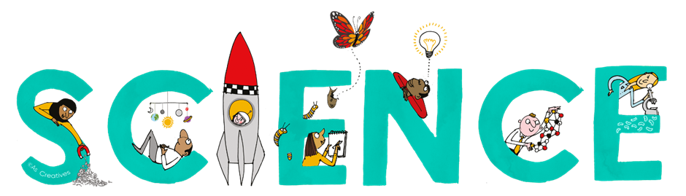


Subject Newsletter - Year 11 - (Spring term)

Useful contacts / information  Helen Hawke - Faculty Leader  hhawke@brookvalegroby.com  Ross Dixey - Asst Faculty leader (Tassomai link)  rdixey@brookvalegroby.com  Dina Gajjar - Asst Faculty Leader (KS3 link / progress lead)  dgajjar@brookvalegroby.com   |  | What are we learning this term?  Combined science  B6 Inheritance, variation and evolution  C4 Chemical changes  C5 Energy changes  P6 Waves  Separate science - Biology  B6 Inheritance, variation and evolution  Separate science - Chemistry  C4 Chemical changes  C5 Energy changes  Separate science - Physics  P5b Forces in action  P7 Magnetism



Enrichment  16th - 20th March British Science week Assemblies  Fri 4th April - Science exam warm up assembly |  | Homework  Combined science - 3 daily goals on Tassomai  Separate science - 4 daily goals on Tassomai |  | Assessments  End of module tests for all modules  9th - 13th March - Year 11 mock exams

“Nothing in life is to be feared, it is only to be understood. Now is the time to understand more, so that we may fear less.” – Marie Curie

