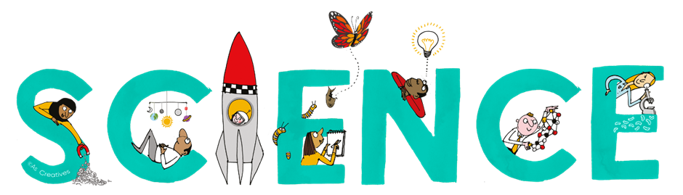


Science Newsletter - Year 7

Useful contacts / information  Helen Hawke - Faculty Leader  hhawke@brookvalegroby.com  Dina Gajjar - Asst Faculty Leader (KS3 link / Progress Lead)  dgajjar@brookvalegroby.com  Ross Dixey - Asst Faculty leader (Tassomai link)  rdixey@brookvalegroby.com   |  | What are we learning this term?  Organisms 1 - Movement (explore how the skeletal system and muscular system work together to cause movement) and cells (identify the principal feature of cells and describe their function  Forces 1 - Speed (investigate variables on the speed of a car rolling down a slope) and gravity (explain the link between gravity and the distance between objects)  Matter 1 - particle model (use models models to investigate the relationship between the properties of a material and th arrangement of particles) and separating mixtures (devise ways to a separate mixtures,  based on their properties)



Enrichment  Science club |  | Homework  Science - 3 daily goals on Tassomai |  | Assessments  End of module tests for all modules

“Scientists have become the bearers of the torch of discovery in our quest for knowledge.” – Stephen Hawking

