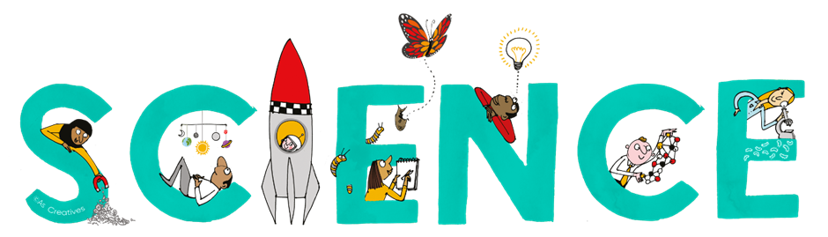


Subject Newsletter - Year 7 - (Spring term)

Useful contacts / information  Helen Hawke - Faculty Leader  hhawke@brookvalegroby.com  Dina Gajjar - Asst Faculty Leader (KS3 link / Progress Lead)  dgajjar@brookvalegroby.com  Ross Dixey - Asst Faculty leader (Tassomai link)  rdixey@brookvalegroby.com   |  | What are we learning this term?  Waves 1 - Sound (Relate changes in the shape of an  oscilloscope trace to changes in pitch and volume) and light (Use ray diagrams to model how light passes through lenses and transparent materials)  Reactions 1 - Metals and non-metals (Use  experimental results to suggest an order of reactivity  of various metals) and Acids and alkalis (Devise an  enquiry to compare how well indigestion remedies work)  Genes 1 - Variation (Graph data relating to variation and  explain how it may lead to the survival of a species)  and human reproduction (Relate advice to pregnant  women to ideas about transfer of substances to the embryo)  Revision for end of year assessment



Enrichment  16th - 20th March British Science week Assemblies  Poster competition |  | Homework  Science - 3 daily goals on Tassomai |  | Assessments  End of module tests for all modules  Revision for year 7 exam (27th April - 1st May)

“Nothing in life is to be feared, it is only to be understood. Now is the time to understand more, so that we may fear less.” – Marie Curie
th

