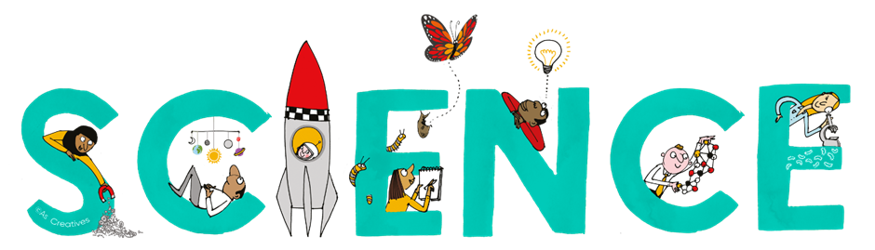


Subject Newsletter - Year 8 - (Spring term)

Useful contacts / information  Helen Hawke - Faculty Leader  hhawke@brookvalegroby.com  Dina Gajjar - Asst Faculty Leader (KS3 link / Progress Lead)  dgajjar@brookvalegroby.com  Ross Dixey - Asst Faculty leader (Tassomai link)   |  | What are we learning this term?  Electromagnets 1 - Voltage and resistance (Compare  the voltage drop across resistors connected in series in a  circuit) and current (Compare and explain current flow  in different parts of a parallel circuit)  Genes 2 - Evolution (Review the evidence for theories  about how a particular species went extinct and inheritance (Model the inheritance of a specific trait and  explore the variation in the offspring produced)  Earth 2 - Climate (Investigate the contribution that natural and human chemical processes make to our carbon dioxide emissions) and Earth resources (Predict the method used for extracting a metal based on its  position in the reactivity series)  Revision for the year 8 exam



Enrichment  16th - 20thMarch British Science week Assemblies  Poster competition Engineering Masterclass |  | Homework  Science - 3 daily goals on Tassomai |  | Assessments  End of module tests for all modules  Revision for Year 8 exams (20th - 24th April)

“Nothing in life is to be feared, it is only to be understood. Now is the time to understand more, so that we may fear less.” – Marie Curie

