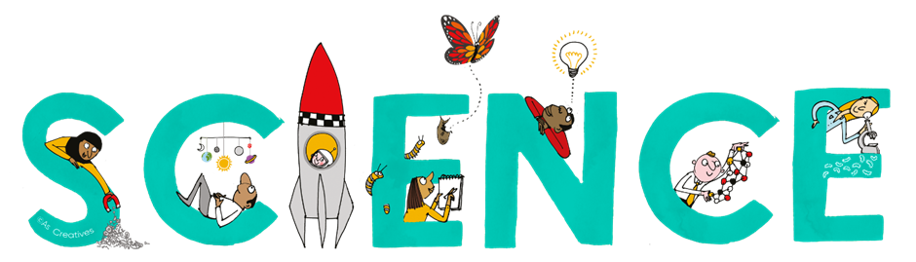


Subject Newsletter - Year 9 - (Autumn term)

Useful contacts / information  Helen Hawke - Faculty Leader  hhawke@brookvalegroby.com  Dina Gajjar - Asst Faculty Leader (KS3 link / Progress  Lead)  dgajjar@brookvalegroby.com  Ross Dixey - Asst Faculty leader (Tassomai link)  rdixey@brookvalegroby.com   |  | What are we learning this term?  Environment 2 - Respiration ( use data from investigating fermentation with yeast to explore respiration) and photosynthesis (use lab tests on variegated leaves to show that chlorophyll is essential for photosynthesis)  Electromagnets 2 - Electromagnets (investigate ways of varying the strength of an electromagnet) and magnetism (explore the magnetic field pattern around different types or combinations of magnets)  Waves 2 - Wave effects (Relate the impacts of different types of wave on living cells to their frequency and the energy carried by the wave and their uses)  and wave properties ( use the wave model to  explain observations of the reflection,  absorption and transmission of waves  Reactions 2 - Chemical energy (Investigate a phenomenon that relies on an exothermic or endothermic reaction) and types of reaction (Investigate  changes in mass for chemical and physical processes)



Enrichment  Science careers assembly  Science club  Psychology Masterclass |  | Homework  Science - 3 daily goals on Tassomai |  | Assessments  End of module tests for all modules

“Scientists have become the bearers of the torch of discovery in our quest for knowledge.” – Stephen Hawking

