
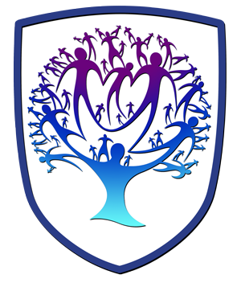
Lifeskills Newsletter - Year 10
Personal, Social, Health and Relationships Education

Useful contacts / information  Beth Rumming  Head of Faculty - Lifeskills and Careers  brumming@brookvalegroby-tmet.uk |  | Year 10 are learning this term:  - Mental wellbeing  - Marriage and Civil Partnerships  - Vaping  - Contraception  - Foetal development and routes into parenthood  - Body image (dangers of social media)  - Revenge images  - Anti-bullying  - Gambling  - Cosmetic and Plastic Surgery  - Appreciating diversity  - British Values


Lifeskills Enrichment  The lifeskills curriculum fits into the whole school Personal Development offer and is enriched by the LORIC tutor time programme and assemblies throughout the year which build upon themes covered in Lifeskills lessons throughout the 5 year course. |  | Homework  Whilst there is no compulsory homework for Lifeskills, students are encouraged to take an interest in the news to keep up to date with current affairs so that they can make informed decisions . |  | Assessments  - Google Quiz before the end of term

