
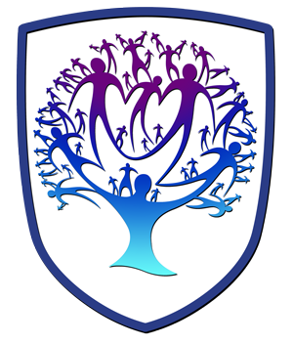
Lifeskills Newsletter - Year 11
Personal, Social, Health and Relationships Education

Useful contacts / information  Beth Rumming  Head of Faculty - Lifeskills and Careers  brumming@brookvalegroby-tmet.uk |  | Year 11 are learning this term:  - Mental wellbeing  - Digital content: Bias and Extremism  - Pressure and rejection  - First aid  - Ending and improving relationships  - Sexuality  - Sexual Health  - Introduction to the PS16 application system  - Personal statement writing  - Mock interview preparation  - Begin PS16 application in Lifeskills lessons


Lifeskills Enrichment  This term, Year 11 will be sitting through a mock-interview with external businesses which will help to prepare them for Post-16 interviews. They will also receive enrichment from the Careers team to help with Post-16 decision making. |  | Homework  Whilst there is no compulsory homework for Lifeskills, Year 11 students are encouraged to visit open days for any Post-16 providers that they are interested in so that they make an informed decision about their Post-16 education |  | Assessments  Year 11 do not complete any assessments in Lifeskills.

