
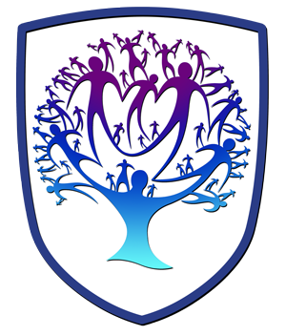
Lifeskills Newsletter - Year 8
Personal, Social, Health and Relationships Education

Useful contacts / information  Beth Rumming  Head of Faculty - Lifeskills and Careers  brumming@brookvalegroby-tmet.uk |  | Year 8 are learning this term:  - Wellbeing  - Effects of Alcohol  - Fake news and Echo chambers  - Community  - Anti-bullying  - Prejudice and Discrimination  - Money (understanding Debt)


Lifeskills Enrichment  The lifeskills curriculum fits into the whole school Personal Development offer and is enriched by the LORIC tutor time programme and assemblies throughout the year which build upon themes covered in Lifeskills lessons throughout the 5 year course. |  | Homework  Whilst there is no compulsory homework for Lifeskills, students are encouraged to take an interest in the news to keep up to date with current affairs so that they can make informed decisions . |  | Assessments  - Google Quiz before the end of term

