

BGLC FACULTY OF ENGLISH, MEDIA AND CAMPUS LIBRARY
Work Hard, Be Kind…and be ambitious
SKILLS FOR SUCCESS HANDBOOK YR 9: 2025/26

This handbook belongs to:

Use this handbook in every lesson to help your understanding and progress

Literacy drives everything that we do. This is what literacy looks like in our classroom:
 | 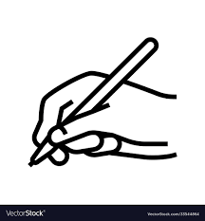 | 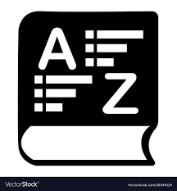 | 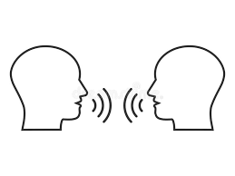
Reading | Writing | Vocabulary | Oracy
This is a reading classroom where your teacher will model reading, and you will read. You will read for pleasure and for empowerment. | This is a writing classroom where you are shown how to write your responses through your teacher modelling, followed by your deliberate practice. | This is a classroom where you are shown new words - words you need to understand the subject, or words to help you express your ideas clearly. | This is a classroom where you have the opportunity to speak and listen to other speakers with tolerance and respect; share your ideas for feedback.

Rules for success in our English classroom:
  listen |   be kind |   do your best work
* the teacher is the expert - respect the expert  * raise your hand to ask a question & join a discussion  * wait your turn, don't interrupt  * accept different opinions | * every student has the right to learn - respect each other  * respond politely to greetings and instructions, be polite in return  * offer to help someone who is struggling | * write the date and learning question clearly  * draw tables or grids with a ruler  * ensure your work is neat and doodle-free  * be proud of something every day

