
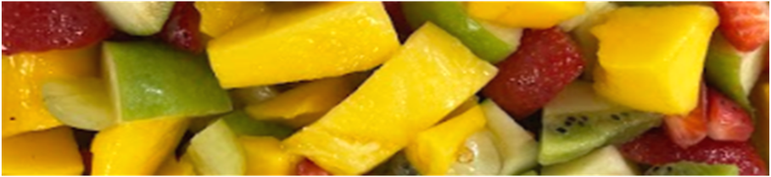

Food - Year 7 - Health and Hygiene

Useful contacts / information  ebrayne@brookvalegroby-tmet.uk-  Subject lead  cdepledge@brookvalegroby-tmet.uk  Subject teacher  If you have any questions, please do not hesitate to contact your son/daughter’s subject  teacher or the    Subject Lead |  | What are we learning this term?  Students start learning about health and safety in the kitchen.  This covers food, the kitchen environment, how to store food, food poisoning and personal hygiene. Students also develop an understanding of where our foods come from and of key nutrients.  Students complete various food planning activities and sensory analysis tasks.  Do-Now general knowledge is included in written lessons.  Students learn how to use basic knife skills and make a Fruit salad.  Students then move onto making scones, developing their cooking skills and understanding of the function of ingredients.  Making white sauce is next, which teaches students how to use the hob and how to thicken a sauce to boil and vegetables safely.    Oaty biscuits introduce students to the melting method and increasing fibre content of food.

Enrichment  An ADT Enrichment Google Classroom is created for students to use.  Students can adapt recipes to suit the needs of people at home.  Research new recipes and cook at home, bringing in pictures to display in school and gain rewards.  Competitions at various times of the year are held.   |  | Homework  Students are responsible for making sure they have the correct ingredients and containers organised ready for practical food lessons. Recipe sheets are given out to students at the start of their rotation and are posted on the Google classroom. Recipes may be adapted to suit dietary needs.  Students have access to Knowledge Organisers to support them with home learning (20:20:20)  A subject drive has been created for all students so that they have access to all materials to help    them at home. This is shared with students in  lessons. |  | Assessments  A Midpoint assessment is made after week 3 and at the end of the rotation weeks.  Practical lessons are reviewed during each practical lesson and feedback given.  Students are marked in relation to the unit checklist (personalised learning checklist). It is communicated if they are Exceeding, Meeting or  are Developing within the    subject.

‘’No one is born a great cook, one learns by doing’’ - Julia Child

