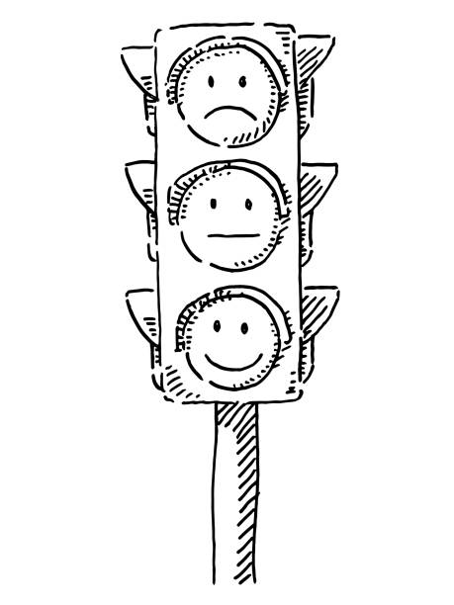
Yr 7: At the beginning of the year and after each of your key assessments, you will complete a PLC so you can track your progress and think about what you need to do to improve.

R = Red. I am not confident with this skill, do not use it regularly and often need help.
A = Amber. I am fairly confident with this skill, sometimes use this in my writing, and sometimes need help.
G = Green. I am very confident with this skill, use it regularly and correctly in my writing and rarely need help.

START OF THE YEAR | R | A | G
I use capital letters to indicate a new sentence or a proper noun
I use a variety of punctuation in my sentences ( . , ; : - )
I use apostrophes for possession and contractions
I use quote marks in my writing
I write in complete sentences
I sustain the correct tense throughout my writing
I understand how clauses build sentences and I use connectives
I can Identify and use the grammatically correct homophone (eg there, their, they're; to, too; here, hear; which, witch; where, wear, we're etc.)
I am most confident with:
I am improving with my use of:
My focus for improving this half term is:

KEY ASSESSMENT ONE - CREATIVE WRITING. | R | A | G
I use capital letters to indicate a new sentence or a proper noun
I use a variety of punctuation in my sentences ( . , ; : - )
I use apostrophes for possession and contractions
I use quote marks in my writing
I write in complete sentences
I sustain the correct tense throughout my writing
I understand how clauses build sentences and I use connectives
I can Identify and use the grammatically correct homophone (eg there, their, they're; to, too; here, hear; which, witch; where, wear, we're etc.)
I am most confident with:
I am improving with my use of:
My focus for improving this half term is:

KEY ASSESSMENT TWO - SPEAKING AND LISTENING | R | A | G
I can listen without interrupting the speaker
I can understand their ideas
I can ask the speaker questions about their speech
I can speak clearly and slowly so my listeners can follow me
I can vary my tone for emphasis
I can use interesting and varied vocabulary
I can pause for effect at the appropriate point in my speech
I am most confident with:
I am improving with my use of:
My focus for improving this half term is:

KEY ASSESSMENT THREE - CREATIVE WRITING. | R | A | G
I use capital letters to indicate a new sentence or a proper noun
I use a variety of punctuation in my sentences ( . , ; : - )
I use apostrophes for possession and contractions
I use quote marks in my writing
I write in complete sentences
I sustain the correct tense throughout my writing
I understand how clauses build sentences and I use connectives
I can Identify and use the grammatically correct homophone (eg there, their, they're; to, too; here, hear; which, witch; where, wear, we're etc.)
I am most confident with:
I am improving with my use of:
My focus for improving this half term is:

I think I have improved the most in ______________________________________________________

In year 8, I want to improve ____________________________________________________________
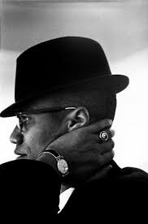

Education is the passport to the future, for tomorrow belongs to those who prepare for it today.

Malcolm X (1925-1965) African American human rights activist

