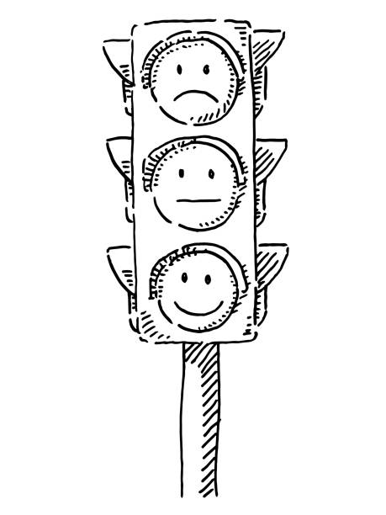
Yr 9: At the beginning of the year and after each of your key assessments, you will complete a PLC so you can track your progress and think about what you need to do to improve.

R = Red. I am not confident with this skill, do not use it regularly and often need help.
A = Amber. I am fairly confident with this skill, sometimes use this in my writing, and sometimes need help.
G = Green. I am very confident with this skill, use it regularly and correctly in my writing and rarely need help.

START OF THE YEAR | R | A | G
I use capital letters to indicate a new sentence or a proper noun
I use a variety of punctuation in my sentences ( . , ; : - )
I use apostrophes for possession and contractions
I use quote marks in my writing
I write in complete sentences
I sustain the correct tense throughout my writing
I understand how clauses build sentences and I use connectives
I can Identify and use the grammatically correct homophone (eg there, their, they're; to, too; here, hear; which, witch; where, wear, we're etc.)
I am most confident with:
I am improving with my use of:
My focus for improving this half term is:

KEY ASSESSMENT ONE - CREATIVE WRITING. | R | A | G
I use capital letters to indicate a new sentence or a proper noun
I use a variety of punctuation in my sentences ( . , ; : - )
I use apostrophes for possession and contractions
I use quote marks in my writing
I write in complete sentences
I sustain the correct tense throughout my writing
I understand how clauses build sentences and I use connectives
I can Identify and use the grammatically correct homophone (eg there, their, they're; to, too; here, hear; which, witch; where, wear, we're etc.)
I am most confident with:
I am improving with my use of:
My focus for improving this half term is:

KEY ASSESSMENT TWO - UNSEEN POETRY | R | A | G
I can make my own meaning from a poem I haven't seen before
I can make some annotations on the poem to support my ideas
I can say something about the opening, imagery, and ending
I can identify the writer's methods
I can discuss the effect of the writer's methods (how it makes me feel)
I can use interesting and varied vocabulary
I can use appropriate discourse markers
I am most confident with:
I am improving with my use of:
My focus for improving this half term is:

KEY ASSESSMENT THREE - SPEAKING AND LISTENING. | R | A | G
I can listen without interrupting the speaker
I can understand their ideas
I can ask the speaker questions about their speech
I can speak clearly and slowly so my listeners can follow me
I can vary my tone for emphasis
I can use interesting and varied vocabulary
I can pause for effect at the appropriate point in my speech
I am most confident with:
I am improving with my use of:
My focus for improving this half term is:

I think I have improved the most in ______________________________________________________

In year 10, I want to improve ___________________________________________________________
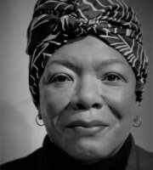

I did then what I knew how to do. Now that I know better, I do better

Maya Angelou (1928-2014) African American memoirist, poet and civil rights activist

